UNITED STATES
SECURITIES AND EXCHANGE COMMISSION
Washington, DC 20549
FORM 8-K
CURRENT REPORT PURSUANT TO SECTION 13 OR 15(d) OF
THE SECURITIES EXCHANGE ACT OF 1934

Date of Report (Date of earliest event reported): 7/31/2026
Gaming and Leisure Properties, Inc.
(Exact name of registrant as specified in its charter)
Pennsylvania |  |  |  |  |  | 001-36124 |  |  |  |  |  | 46-2116489
(State or Other Jurisdiction of  Incorporation or Organization) |  |  |  |  |  | (Commission File Number) |  |  |  |  |  | (IRS Employer Identification No.)
845 Berkshire Blvd., Suite 200
Wyomissing, PA 19610
(Address of principal executive offices)

610-401-2900
(Registrant’s telephone number, including area code)

Check the appropriate box below if the Form 8-K filing is intended to simultaneously satisfy the filing obligation of the registrant under any of the following provisions (see General Instruction A.2 below):

☐ Written communications pursuant to Rule 425 under the Securities Act (17 CFR 230.425)

☐ Soliciting material pursuant to Rule 14a-12 under the Exchange Act (17 CFR 240.14a-12)

☐ Pre-commencement communications pursuant to Rule 14d-2(b) under the Exchange Act (17 CFR 240.14d-2(b))

☐ Pre-commencement communications pursuant to Rule 13e-4(c) under the Exchange Act (17 CFR 240.13e-4(c))

Securities registered pursuant to Section 12(b) of the Act:
Title of each class |  |  |  |  |  | Trading Symbol(s) |  |  |  |  |  | Name of each exchange on which registered
Common Stock, par value $.01 per share |  |  |  |  |  | GLPI |  |  |  |  |  | Nasdaq
Indicate by check mark whether the registrant is an emerging growth company as defined in Rule 405 of the Securities Act of 1933 (§230.405 of this chapter) or Rule 12b-2 of the Securities Exchange Act of 1934 (§240.12b-2 of this chapter).

Emerging growth company ☐

If an emerging growth company, indicate by check mark if the registrant has elected not to use the extended transition period for complying with any new or revised financial accounting standards provided pursuant to Section 13(a) of the Exchange Act. ☐

Item 2.02. Results of Operations and Financial Condition.

On July 30, 2026, Gaming and Leisure Properties, Inc. issued a press release announcing its financial results for the three and six months ended June 30, 2026. A copy of the press release is attached hereto as Exhibit 99.1 and incorporated herein by reference.

The information in this Current Report on Form 8-K, including Exhibit 99.1, is being furnished pursuant to Item 2.02 and shall not be deemed to be “filed” for the purposes of Section 18 of the Securities Exchange Act of 1934, as amended (the “Exchange Act”), or otherwise subject to the liabilities of that section and shall not be incorporated by reference into any filing under the Securities Act of 1933, as amended, or the Exchange Act, except as shall be expressly set forth by specific reference in such filing.

Item 9.01. Financial Statements and Exhibits.

(d) Exhibits

Exhibit  Number |  |  |  |  |  | Description
99.1 |  |  |  |  |  | Gaming and Leisure Properties, Inc. Earnings Press Release, dated July 30, 2026
99.2 |  |  |  |  |  | Supplemental Financial Information, Second Quarter Ended June 30, 2026
104 |  |  |  |  |  | The cover page from the Company's Current Report on Form 8-K, dated July 31, 2026, formatted in Inline XBRL.

* * *
2

SIGNATURE

Pursuant to the requirements of the Securities Exchange Act of 1934, the Registrant has duly caused this report to be signed on its behalf by the undersigned hereunto duly authorized.

Dated: July 31, 2026 |  |  | GAMING AND LEISURE PROPERTIES, INC.
 |  |  | By: |  |  | /s/ Desiree A. Burke
 |  |  | Name: |  |  | Desiree A. Burke
 |  |  | Title: |  |  | Chief Financial Officer and Treasurer

3


GAMING AND LEISURE PROPERTIES REPORTS RECORD SECOND QUARTER RESULTS AND UPDATES 2026 FULL YEAR GUIDANCE

WYOMISSING, PA — July 30, 2026 — Gaming and Leisure Properties, Inc. (NASDAQ: GLPI) (“GLPI” or the “Company”) today announced financial results for the quarter ended June 30, 2026.

Financial Highlights

 |  |  |  |  |  | Three Months Ended June 30,
(in millions, except per share data) |  |  |  |  |  | 2026 |  |  |  |  |  |  |  | 2025
Total Revenue |  |  |  |  |  | $ | 430.5 |  |  |  |  |  |  | $ | 394.9
Income from Operations |  |  |  |  |  | $ | 332.4 |  |  |  |  |  |  | $ | 242.1
Net Income |  |  |  |  |  | $ | 234.9 |  |  |  |  |  |  | $ | 156.2
FFO (1) (4) |  |  |  |  |  | $ | 302.3 |  |  |  |  |  |  | $ | 224.9
AFFO (2) (4) |  |  |  |  |  | $ | 304.0 |  |  |  |  |  |  | $ | 276.1
Adjusted EBITDA (3) (4) |  |  |  |  |  | $ | 405.5 |  |  |  |  |  |  | $ | 361.5
Net income, per diluted common share |  |  |  |  |  | $ | 0.80 |  |  |  |  |  |  | $ | 0.54
FFO, per diluted common share and OP/LTIP units (4) |  |  |  |  |  | $ | 1.03 |  |  |  |  |  |  | $ | 0.79
AFFO, per diluted common share and OP/LTIP units (4) |  |  |  |  |  | $ | 1.03 |  |  |  |  |  |  | $ | 0.96
Annualized dividend per share |  |  |  |  |  | $ | 3.28 |  |  |  |  |  |  | $ | 3.12
Dividend yield based on period end stock price |  |  |  |  |  | 7.4 |  | % |  |  |  |  |  | 6.7 |  | %

(1) Funds from Operations ("FFO") is net income, excluding (gains) or losses from dispositions of property and real estate depreciation as defined by NAREIT.

(2) Adjusted Funds From Operations ("AFFO") is FFO, excluding, as applicable to the particular period, stock-based compensation expense; the amortization of debt issuance costs, bond premiums and original issuance discounts; other depreciation; amortization of land rights; accretion on investment in leases; non-cash adjustments to financing lease liabilities; straight-line rent and deferred rent adjustments; losses on debt extinguishment and other financing costs; severance charges; capitalized interest; and provision (benefit) for credit losses, net, reduced by capital maintenance expenditures.

(3) Adjusted EBITDA is net income, excluding, as applicable to the particular period, interest, net; income tax expense; real estate depreciation; other depreciation; (gains) or losses from dispositions of property; stock-based compensation expense; straight-line rent and deferred rent adjustments; amortization of land rights; accretion on investment in leases; non-cash adjustments to financing lease liabilities; losses on debt extinguishment and other financing costs; severance charges; and provision (benefit) for credit losses, net.

(4) Metrics are presented assuming full conversion of limited partnership units to common shares and therefore before the effect on net income attributable to noncontrolling interests.

Peter Carlino, Chairman and Chief Executive Officer of GLPI, commented, "Our second quarter results marked another period of record revenue, AFFO and Adjusted EBITDA. On an operating basis, second quarter total revenue rose 9.0% to $430.5 million, AFFO grew 10.1% to $304.0 million, and Adjusted EBITDA increased 12.2% to $405.5 million. The record results highlight GLPI’s unmatched ability to structure complex transactions and deliver creative funding solutions for quality tenants, while maintaining structurally strong lease coverage, an output of our disciplined underwriting approach. Recent acquisitions and an expanding base of leading regional gaming operators and tribal relationships are fueling our pipeline, while financial flexibility remains a core tenet of the Company. Reflecting this momentum, we raised the midpoint of our 2026 AFFO per share guidance, as we are now forecasting a range of $4.10 to $4.12. During the quarter, we also raised our quarterly
1
dividend to $0.82 per share, marking a 5.1% increase over the prior $0.78 dividend per share. As of June 30, 2026, our annualized dividend implied yield was 7.4%.

“We remain very encouraged by trends across the regional gaming landscape, with same-store operator results showing healthy year over year gains through the mid-point of the calendar year, following a strong second quarter for the regional gaming sector.

“Concurrent with strengthening tenant fundamentals, GLPI's 2026 growth has been driven by multiple development projects, investments in tenant facility upgrades, and executed sale-leaseback transactions. During the second quarter, we invested $191 million in tenant developments and completed the $225 million funding commitment for PENN Entertainment's Hollywood Casino Aurora land-based conversion. In the second half of 2026, GLPI anticipates additional development funding of approximately $400 million to $450 million, bringing the 2026 total development spend to a range of $750 million to $800 million, in line with our prior commentary. This activity, coupled with future funding plans, will continue to drive AFFO per share growth through 2027 and into 2028.

“As of June 30, GLPI’s leverage stood at 4.8x, below the low end of our target range of 5.0x to 5.5x net debt to adjusted EBITDA. We expect to remain at or near the low end of the target leverage range as we execute on our announced pipeline. Our balance sheet position continues to provide financial flexibility when evaluating new transactions, and, moreover, allows us to drive accretive and accelerating AFFO growth, without the need for additional equity.

“Looking at the balance of the year, GLPI remains well positioned for growth, both in the near and long-term, supported by our strong operator relationships, our rights and options to participate in select tenants’ future growth and expansion, a healthy deal pipeline, and our ability to competitively structure and fund innovative transactions. In addition, our solid balance sheet and liquidity position the Company to grow cash flows, support future dividend growth, and build value for shareholders over the medium and long-term.”

Recent Developments

•On June 30, 2026, the Company entered into a second amendment to its loan related to the Hard Rock Casino Rockford, pursuant to which the borrower repaid $16.0 million of principal. The amendment also provides for scheduled future principal repayments on or before March 31, 2028, and March 31, 2029. The maturity date was extended to December 31, 2029, and includes an option for GLPI to acquire the building improvements at Hard Rock Casino Rockford.

•On June 24, 2026, the Company funded $216.3 million to complete the $225 million commitment on the Aurora landside development project for PENN Entertainment, Inc. (NASDAQ: PENN) ("PENN") at a 7.75% capitalization rate.

•On June 1, 2026, the Company settled a forward sale agreement pursuant, to which it issued 7,589,487 shares of common stock and raised net proceeds of $351.0 million.

•On March 4, 2026, the Company issued $800 million of senior notes due on March 1, 2036. The notes were priced at 99.857% of par value, with a coupon of 5.625%. The Company used the net proceeds to repay borrowings outstanding under the Company's term loan credit facility, as well as for working capital and general corporate purposes.

•On February 11, 2026, GLPI exercised its option to acquire the real property assets of Bally’s Twin River Lincoln Casino Resort for a purchase price of $700 million and additional annual rent of $56.0 million (8.0% cap rate). The Company issued 332,890 OP Units in connection with the transaction, with the balance of the consideration paid in cash.

•On January 15, 2026, GLPI entered into a development agreement with The Cordish Companies ("Cordish") to fund up to $440 million of real estate construction costs for the Live! Virginia Casino & Hotel and acquired the project land for $27 million, representing a total commitment of $467 million at an 8.0% cap rate.

Dividends
On May 20, 2026, the Company announced that its Board of Directors declared a second quarter dividend of $0.82 per share on the Company's common stock that was paid on June 26, 2026 to shareholders of record on June 12, 2026.

2
2026 Guidance

Reflecting the current operating and competitive environment, the Company is updating its AFFO guidance for the full year 2026 based on the following assumptions and other factors:

•The guidance does not include the impact on operating results from any possible future acquisitions or dispositions, future capital markets activity, or other future non-recurring transactions that have yet to be announced. The updated guidance incorporates the additional development fundings of approximately $400 million to $450 million, which will be funded relatively evenly by quarter throughout the remainder of 2026, which will bring total development spending for 2026 to a range of $750 million to $800 million.
•The guidance assumes there will be no material changes in applicable legislation, regulatory environment, world events, including weather, recent consumer trends, economic conditions, oil prices, competitive landscape or other circumstances beyond our control that may adversely affect the Company's results of operations.

The Company estimates AFFO for the year ending December 31, 2026 will be between $1.219 billion and $1.225 billion, or between $4.10 and $4.12 per diluted share and OP/LTIP units. GLPI's prior guidance contemplated AFFO for the year ending December 31, 2026 of between $1.212 billion and $1.223 billion, or between $4.08 and $4.12 per diluted share and OP/LTIP units.

The Company does not provide a reconciliation for non-GAAP estimates on a forward-looking basis, including the information above, where it is unable to provide a meaningful or accurate calculation or estimation of reconciling items and the information is not available without unreasonable effort. This is due to the inherent difficulty of forecasting the timing and/or amounts of various items that would impact net income, which is the most directly comparable forward-looking GAAP financial measure. This includes, for example, provision for credit losses, net, and other non-core items that have not yet occurred, are out of the Company’s control and/or cannot be reasonably predicted. For the same reasons, the Company is unable to address the probable significance of the unavailable information. In particular, the Company is unable to predict with reasonable certainty the amount of the change in the provision for credit losses, net, under ASU No. 2016-13 - Financial Instruments - Credit Losses ("ASC 326") in future periods. The non-cash change in the provision for credit losses under ASC 326 with respect to future periods is dependent upon future events that are entirely outside of the Company's control and may not be reliably predicted, including the performance and future outlook of our tenant's operations for our leases that are accounted for as investment in leases, as well as broader macroeconomic factors and future predictions of such factors. As a result, forward-looking non-GAAP financial measures provided without the most directly comparable GAAP financial measures may vary materially from the corresponding GAAP financial measures.

Portfolio Update

GLPI's primary business consists of acquiring, financing, and owning real estate property to be leased to gaming operators in triple-net lease arrangements. The Company also extends loans that produce fixed or variable returns which may convert into leased rent upon project completion or stabilization. As of June 30, 2026, GLPI's portfolio consisted of interests in 71 gaming and related facilities, including the real property associated with 34 gaming and related facilities operated by PENN, the real property associated with 6 gaming and related facilities operated by Caesars Entertainment, Inc. (NASDAQ: CZR) ("Caesars"), the real property associated with 4 gaming and related facilities operated by Boyd Gaming Corporation (NYSE: BYD) ("Boyd"), the real property associated with 16 gaming and related facilities operated by Bally's Corporation (NYSE: BALY) ("Bally's"), 2 facilities under development; one with Bally's in Chicago, Illinois, and the other for Cordish and Bruce Smith Enterprise in Petersburg, Virginia, the real property associated with 3 gaming and related facilities operated by Cordish, 1 gaming and related facility operated by American Racing & Entertainment LLC ("American Racing"), 4 gaming and related facilities operated by Strategic Gaming Management, LLC ("Strategic") and 1 facility managed by a subsidiary of Hard Rock International ("Hard Rock"). These facilities are geographically diversified across 21 states.

3
Conference Call Details

The Company will hold a conference call on July 31, 2026, at 10:00 a.m. (Eastern Time) to discuss its financial results, current business trends and market conditions.

To Participate in the Telephone Conference Call:
Dial in at least five minutes before the scheduled start time.
Domestic: 1-877/407-0784
International: 1-201/689-8560

Conference Call Playback:
Domestic: 1-844/512-2921
International: 1-412/317-6671
Passcode: 13761467
The playback can be accessed through Friday, August 7, 2026.

Webcast
The conference call will be available in the Investor Relations section of the Company's website at www.glpropinc.com. To listen to a live broadcast, go to the site at least 15 minutes prior to the scheduled start time in order to register, download and install any necessary software. A replay of the call will also be available for 90 days thereafter on the Company’s website.

4
GAMING AND LEISURE PROPERTIES, INC. AND SUBSIDIARIES
Consolidated Statements of Income and Comprehensive Income
(in thousands, except per share data) (unaudited)

 |  |  | Three Months Ended June 30, |  |  |  |  |  |  |  |  |  |  |  | Six Months Ended June 30,
 |  |  | 2026 |  |  |  |  |  | 2025 |  |  |  |  |  | 2026 |  |  |  |  |  | 2025
Revenues
Rental income |  |  | $ | 366,204 |  |  |  |  | $ | 339,527 |  |  |  |  | $ | 722,726 |  |  |  |  | $ | 679,779
Income from investment in leases, financing receivables |  |  | 52,854 |  |  |  |  |  | 47,926 |  |  |  |  |  | 105,556 |  |  |  |  |  | 95,690
Income from investment in leases, sales-type |  |  | 3,837 |  |  |  |  |  | 3,762 |  |  |  |  |  | 7,675 |  |  |  |  |  | 7,522
Interest income from real estate loans |  |  | 7,624 |  |  |  |  |  | 3,661 |  |  |  |  |  | 14,547 |  |  |  |  |  | 7,120
Total income from real estate |  |  | 430,519 |  |  |  |  |  | 394,876 |  |  |  |  |  | 850,504 |  |  |  |  |  | 790,111
Operating expenses
Land rights and ground lease expense |  |  | 14,149 |  |  |  |  |  | 13,942 |  |  |  |  |  | 27,947 |  |  |  |  |  | 27,497
General and administrative |  |  | 13,245 |  |  |  |  |  | 15,907 |  |  |  |  |  | 31,183 |  |  |  |  |  | 34,620
Losses (gains) from dispositions of property |  |  | 1,170 |  |  |  |  |  | — |  |  |  |  |  | 1,170 |  |  |  |  |  | (125)
Depreciation |  |  | 66,583 |  |  |  |  |  | 69,235 |  |  |  |  |  | 131,620 |  |  |  |  |  | 134,247
Provision (benefit) for credit losses, net |  |  | 2,980 |  |  |  |  |  | 53,728 |  |  |  |  |  | (7,157) |  |  |  |  |  | 92,974
Total operating expenses |  |  | 98,127 |  |  |  |  |  | 152,812 |  |  |  |  |  | 184,763 |  |  |  |  |  | 289,213
Income from operations |  |  | 332,392 |  |  |  |  |  | 242,064 |  |  |  |  |  | 665,741 |  |  |  |  |  | 500,898
Other income (expenses)
Interest expense |  |  | (100,705) |  |  |  |  |  | (89,934) |  |  |  |  |  | (196,561) |  |  |  |  |  | (187,206)
Interest income |  |  | 3,858 |  |  |  |  |  | 4,580 |  |  |  |  |  | 6,595 |  |  |  |  |  | 13,936
Losses on debt extinguishment and other financing costs |  |  | — |  |  |  |  |  | — |  |  |  |  |  | (268) |  |  |  |  |  | —
Total other expenses |  |  | (96,847) |  |  |  |  |  | (85,354) |  |  |  |  |  | (190,234) |  |  |  |  |  | (173,270)
Income before income taxes |  |  | 235,545 |  |  |  |  |  | 156,710 |  |  |  |  |  | 475,507 |  |  |  |  |  | 327,628
Income tax expense |  |  | 601 |  |  |  |  |  | 545 |  |  |  |  |  | 1,161 |  |  |  |  |  | 1,109
Net income |  |  | $ | 234,944 |  |  |  |  | $ | 156,165 |  |  |  |  | $ | 474,346 |  |  |  |  | $ | 326,519
Net income attributable to noncontrolling interest in the Operating Partnership |  |  | (6,528) |  |  |  |  |  | (4,726) |  |  |  |  |  | (14,101) |  |  |  |  |  | (9,896)
Net income attributable to common shareholders |  |  | $ | 228,416 |  |  |  |  | $ | 151,439 |  |  |  |  | $ | 460,245 |  |  |  |  | $ | 316,623
Earnings per common share:
Basic earnings attributable to common shareholders |  |  | $ | 0.80 |  |  |  |  | $ | 0.55 |  |  |  |  | $ | 1.62 |  |  |  |  | $ | 1.15
Diluted earnings attributable to common shareholders |  |  | $ | 0.80 |  |  |  |  | $ | 0.54 |  |  |  |  | $ | 1.62 |  |  |  |  | $ | 1.14
Other comprehensive income
Net income |  |  | 234,944 |  |  |  |  |  | 156,165 |  |  |  |  |  | 474,346 |  |  |  |  |  | 326,519
Unrealized gain on cash flow hedges |  |  | — |  |  |  |  |  | 864 |  |  |  |  |  | — |  |  |  |  |  | 864
Reclassification of derivative gain to interest expense |  |  | (24) |  |  |  |  |  | — |  |  |  |  |  | (48)
Comprehensive income |  |  | 234,920 |  |  |  |  |  | 157,029 |  |  |  |  |  | 474,298 |  |  |  |  |  | 327,383
Comprehensive income attributable to noncontrolling interest in the Operating Partnership |  |  | (6,527) |  |  |  |  |  | (4,753) |  |  |  |  |  | (14,099) |  |  |  |  |  | (9,923)
Comprehensive income attributable to common shareholders |  |  | 228,393 |  |  |  |  |  | 152,276 |  |  |  |  |  | 460,199 |  |  |  |  |  | 317,460

5
GAMING AND LEISURE PROPERTIES, INC. AND SUBSIDIARIES
Current Year Revenue Detail
(in thousands) (unaudited)
Three Months Ended June 30, 2026 |  |  | Building base rent |  |  | Land base rent |  |  | Percentage rent and other rental revenue |  |  | Interest income on real estate loans |  |  | Total cash income |  |  | Straight-line rent and deferred rent adjustments |  |  | Ground rent in revenue |  |  | Accretion on leases |  |  | Total income from real estate
Amended PENN Master Lease |  |  | $ | 55,234 |  | $ | 10,758 |  | $ | 6,461 |  | $ | — |  | $ | 72,453 |  | $ | 4,952 |  | $ | 676 |  | $ | — |  | $ | 78,081
PENN 2023 Master Lease |  |  | 66,482 |  |  | — |  |  | 135 |  |  | — |  |  | 66,617 |  |  | 4,128 |  |  | — |  |  | — |  |  | 70,745
Amended Pinnacle Master Lease |  |  | 61,483 |  |  | 17,814 |  |  | 7,584 |  |  | — |  |  | 86,881 |  |  | 1,858 |  |  | 2,248 |  |  | — |  |  | 90,987
PENN Morgantown Lease |  |  | — |  |  | 806 |  |  | — |  |  | — |  |  | 806 |  |  | — |  |  | — |  |  | — |  |  | 806
Caesars Master Lease |  |  | 16,588 |  |  | 5,932 |  |  | — |  |  | — |  |  | 22,520 |  |  | 1,630 |  |  | 330 |  |  | — |  |  | 24,480
Horseshoe St. Louis Lease |  |  | 6,096 |  |  | — |  |  | — |  |  | — |  |  | 6,096 |  |  | 221 |  |  | — |  |  | — |  |  | 6,317
Boyd Master Lease |  |  | 21,157 |  |  | 2,947 |  |  | 3,034 |  |  | — |  |  | 27,138 |  |  | (333) |  |  | 527 |  |  | — |  |  | 27,332
Boyd Belterra Lease |  |  | 748 |  |  | 473 |  |  | 498 |  |  | — |  |  | 1,719 |  |  | (43) |  |  | — |  |  | — |  |  | 1,676
Bally's Master Lease |  |  | 27,106 |  |  | — |  |  | — |  |  | — |  |  | 27,106 |  |  | — |  |  | 2,737 |  |  | — |  |  | 29,843
Bally's Master Lease II |  |  | 29,570 |  |  | — |  |  | — |  |  | — |  |  | 29,570 |  |  | (67) |  |  | 902 |  |  | — |  |  | 30,405
Maryland Live! Lease |  |  | 19,751 |  |  | — |  |  | — |  |  | — |  |  | 19,751 |  |  | — |  |  | 2,129 |  |  | 3,239 |  |  | 25,119
Pennsylvania Live! Master Lease |  |  | 13,168 |  |  | — |  |  | — |  |  | — |  |  | 13,168 |  |  | — |  |  | 315 |  |  | 2,095 |  |  | 15,578
Casino Queen Master Lease |  |  | 3,611 |  |  | — |  |  | — |  |  | — |  |  | 3,611 |  |  | 47 |  |  | — |  |  | — |  |  | 3,658
Tropicana Las Vegas Lease |  |  | — |  |  | 3,838 |  |  | — |  |  | — |  |  | 3,838 |  |  | — |  |  | — |  |  | (1) |  |  | 3,837
Rockford Lease |  |  | — |  |  | 2,081 |  |  | — |  |  | — |  |  | 2,081 |  |  | — |  |  | — |  |  | 531 |  |  | 2,612
Rockford Loan |  |  | — |  |  | — |  |  | — |  |  | 3,033 |  |  | 3,033 |  |  | — |  |  | — |  |  | — |  |  | 3,033
Tioga Downs Lease |  |  | 3,760 |  |  | — |  |  | — |  |  | — |  |  | 3,760 |  |  | — |  |  | 1 |  |  | 551 |  |  | 4,312
Strategic Gaming Leases |  |  | 6,090 |  |  | — |  |  | — |  |  | — |  |  | 6,090 |  |  | — |  |  | 105 |  |  | 912 |  |  | 7,107
Ione Loan |  |  | — |  |  | — |  |  | — |  |  | 2,605 |  |  | 2,605 |  |  | — |  |  | — |  |  | — |  |  | 2,605
Bally's Chicago Lease |  |  | 8,848 |  |  | 5,000 |  |  | — |  |  | — |  |  | 13,848 |  |  | (13,848) |  |  | — |  |  | — |  |  | —
Dry Creek Loan |  |  | — |  |  | — |  |  | — |  |  | 1,446 |  |  | 1,446 |  |  | — |  |  | — |  |  | — |  |  | 1,446
Virginia Live! Development |  |  | — |  |  | — |  |  | — |  |  | 540 |  |  | 540 |  |  | — |  |  | — |  |  | — |  |  | 540
Total |  |  | $ | 339,692 |  | $ | 49,649 |  | $ | 17,712 |  | $ | 7,624 |  | $ | 414,677 |  | $ | (1,455) |  | $ | 9,970 |  | $ | 7,327 |  | $ | 430,519

6
GAMING AND LEISURE PROPERTIES, INC. AND SUBSIDIARIES
Current Year Revenue Detail
(in thousands) (unaudited)
Six Months Ended June 30, 2026 |  |  | Building base rent |  |  | Land base rent |  |  | Percentage rent and other rental revenue |  |  | Interest income on real estate loans |  |  | Total cash income |  |  | Straight-line rent and deferred rent adjustments |  |  | Ground rent in revenue |  |  | Accretion on leases |  |  | Total income from real estate
Amended PENN Master Lease |  |  | $ | 110,469 |  | $ | 21,517 |  | $ | 12,975 |  | $ | — |  | $ | 144,961 |  | $ | 9,904 |  | $ | 1,249 |  | $ | — |  | $ | 156,114
PENN 2023 Master Lease |  |  | 132,624 |  |  | — |  |  | 220 |  |  | — |  |  | 132,844 |  |  | 8,256 |  |  | — |  |  | — |  |  | 141,100
Amended Pinnacle Master Lease |  |  | 122,965 |  |  | 35,628 |  |  | 15,706 |  |  | — |  |  | 174,299 |  |  | 3,716 |  |  | 4,456 |  |  | — |  |  | 182,471
PENN Morgantown Lease |  |  | — |  |  | 1,612 |  |  | — |  |  | — |  |  | 1,612 |  |  | — |  |  | — |  |  | — |  |  | 1,612
Caesars Master Lease |  |  | 33,175 |  |  | 11,864 |  |  | — |  |  | — |  |  | 45,039 |  |  | 3,261 |  |  | 660 |  |  | — |  |  | 48,960
Horseshoe St. Louis Lease |  |  | 12,192 |  |  | — |  |  | — |  |  | — |  |  | 12,192 |  |  | 440 |  |  | — |  |  | — |  |  | 12,632
Boyd Master Lease |  |  | 42,036 |  |  | 5,893 |  |  | 6,080 |  |  | — |  |  | 54,009 |  |  | (2,697) |  |  | 1,053 |  |  | — |  |  | 52,365
Boyd Belterra Lease |  |  | 1,486 |  |  | 947 |  |  | 998 |  |  | — |  |  | 3,431 |  |  | (420) |  |  | — |  |  | — |  |  | 3,011
Bally's Master Lease |  |  | 54,045 |  |  | — |  |  | — |  |  | — |  |  | 54,045 |  |  | — |  |  | 5,336 |  |  | — |  |  | 59,381
Bally's Master Lease II |  |  | 52,607 |  |  | — |  |  | — |  |  | — |  |  | 52,607 |  |  | (133) |  |  | 1,871 |  |  | — |  |  | 54,345
Maryland Live! Lease |  |  | 39,503 |  |  | — |  |  | — |  |  | — |  |  | 39,503 |  |  | — |  |  | 4,168 |  |  | 6,420 |  |  | 50,091
Pennsylvania Live! Master Lease |  |  | 26,185 |  |  | — |  |  | — |  |  | — |  |  | 26,185 |  |  | — |  |  | 616 |  |  | 4,297 |  |  | 31,098
Casino Queen Master Lease |  |  | 6,986 |  |  | — |  |  | — |  |  | — |  |  | 6,986 |  |  | 102 |  |  | — |  |  | — |  |  | 7,088
Tropicana Las Vegas Lease |  |  | — |  |  | 7,676 |  |  | — |  |  | — |  |  | 7,676 |  |  | — |  |  | — |  |  | (1) |  |  | 7,675
Rockford Lease |  |  | — |  |  | 4,162 |  |  | — |  |  | — |  |  | 4,162 |  |  | — |  |  | — |  |  | 1,049 |  |  | 5,211
Rockford Loan |  |  | — |  |  | — |  |  | — |  |  | 6,033 |  |  | 6,033 |  |  | — |  |  | — |  |  | — |  |  | 6,033
Tioga Downs Lease |  |  | 7,476 |  |  | — |  |  | — |  |  | — |  |  | 7,476 |  |  | — |  |  | 3 |  |  | 1,131 |  |  | 8,610
Strategic Gaming Leases |  |  | 12,139 |  |  | — |  |  | — |  |  | — |  |  | 12,139 |  |  | — |  |  | 211 |  |  | 1,843 |  |  | 14,193
Ione Loan |  |  | — |  |  | — |  |  | — |  |  | 4,631 |  |  | 4,631 |  |  | — |  |  | — |  |  | — |  |  | 4,631
Bally's Chicago Lease |  |  | 14,355 |  |  | 10,000 |  |  | — |  |  | — |  |  | 24,355 |  |  | (24,355) |  |  | — |  |  | — |  |  | —
Dry Creek Loan |  |  | — |  |  | — |  |  | — |  |  | 2,882 |  |  | 2,882 |  |  | — |  |  | — |  |  | — |  |  | 2,882
Virginia Live! Development |  |  | — |  |  | — |  |  | — |  |  | 1,001 |  |  | 1,001 |  |  | — |  |  | — |  |  | — |  |  | 1,001
Total |  |  | $ | 668,243 |  | $ | 99,299 |  | $ | 35,979 |  | $ | 14,547 |  | $ | 818,068 |  | $ | (1,926) |  | $ | 19,623 |  | $ | 14,739 |  | $ | 850,504

7
Reconciliation of Net income (GAAP) to FFO, FFO to AFFO, and AFFO to Adjusted EBITDA
Gaming and Leisure Properties, Inc. and Subsidiaries
CONSOLIDATED
(in thousands, except per share and share data) (unaudited)

 |  |  | Three Months Ended June 30, |  |  |  |  |  |  |  |  |  |  |  | Six Months Ended June 30,
 |  |  | 2026 |  |  |  |  |  | 2025 |  |  |  |  |  | 2026 |  |  |  |  |  | 2025
Net income |  |  | $ | 234,944 |  |  |  |  | $ | 156,165 |  |  |  |  | $ | 474,346 |  |  |  |  | $ | 326,519
Losses (gains) from dispositions of property |  |  | 1,170 |  |  |  |  |  | — |  |  |  |  |  | 1,170 |  |  |  |  |  | (125)
Real estate depreciation |  |  | 66,186 |  |  |  |  |  | 68,749 |  |  |  |  |  | 130,738 |  |  |  |  |  | 133,278
Funds from operations |  |  | $ | 302,300 |  |  |  |  | $ | 224,914 |  |  |  |  | $ | 606,254 |  |  |  |  | $ | 459,672
Straight-line rent and deferred rent adjustments |  |  | 1,455 |  |  |  |  |  | (6,433) |  |  |  |  |  | 1,926 |  |  |  |  |  | (14,845)
Other depreciation |  |  | 397 |  |  |  |  |  | 486 |  |  |  |  |  | 882 |  |  |  |  |  | 969
Provision (benefit) for credit losses, net |  |  | 2,980 |  |  |  |  |  | 53,728 |  |  |  |  |  | (7,157) |  |  |  |  |  | 92,974
Amortization of land rights |  |  | 4,270 |  |  |  |  |  | 4,270 |  |  |  |  |  | 8,540 |  |  |  |  |  | 8,540
Amortization of debt issuance costs, bond premiums and original issuance discounts |  |  | 3,635 |  |  |  |  |  | 3,227 |  |  |  |  |  | 7,103 |  |  |  |  |  | 6,459
Capitalized interest |  |  | (8,484) |  |  |  |  |  | (3,411) |  |  |  |  |  | (14,914) |  |  |  |  |  | (7,016)
Stock-based compensation |  |  | 4,644 |  |  |  |  |  | 6,156 |  |  |  |  |  | 12,748 |  |  |  |  |  | 15,014
Losses on debt extinguishment and other financing costs |  |  | — |  |  |  |  |  | — |  |  |  |  |  | 268 |  |  |  |  |  | —
Accretion on investment in leases |  |  | (7,327) |  |  |  |  |  | (6,866) |  |  |  |  |  | (14,739) |  |  |  |  |  | (13,762)
Non-cash adjustment to financing lease liabilities |  |  | 106 |  |  |  |  |  | 107 |  |  |  |  |  | 204 |  |  |  |  |  | 205
Capital maintenance expenditures |  |  | — |  |  |  |  |  | (121) |  |  |  |  |  | — |  |  |  |  |  | (157)
Adjusted funds from operations |  |  | $ | 303,976 |  |  |  |  | $ | 276,057 |  |  |  |  | $ | 601,115 |  |  |  |  | $ | 548,053
Interest, net (1) |  |  | 96,065 |  |  |  |  |  | 84,576 |  |  |  |  |  | 188,411 |  |  |  |  |  | 171,725
Income tax expense |  |  | 601 |  |  |  |  |  | 545 |  |  |  |  |  | 1,161 |  |  |  |  |  | 1,109
Capital maintenance expenditures |  |  | — |  |  |  |  |  | 121 |  |  |  |  |  | — |  |  |  |  |  | 157
Amortization of debt issuance costs, bond premiums and original issuance discounts |  |  | (3,635) |  |  |  |  |  | (3,227) |  |  |  |  |  | (7,103) |  |  |  |  |  | (6,459)
Capitalized interest |  |  | 8,484 |  |  |  |  |  | 3,411 |  |  |  |  |  | 14,914 |  |  |  |  |  | 7,016
Adjusted EBITDA |  |  | $ | 405,491 |  |  |  |  | $ | 361,483 |  |  |  |  | $ | 798,498 |  |  |  |  | $ | 721,601
FFO, per diluted common share and OP/LTIP units |  |  | $ | 1.03 |  |  |  |  | $ | 0.79 |  |  |  |  | $ | 2.07 |  |  |  |  | $ | 1.61
AFFO, per diluted common share and OP/LTIP units |  |  | $ | 1.03 |  |  |  |  | $ | 0.96 |  |  |  |  | $ | 2.05 |  |  |  |  | $ | 1.92
Weighted average number of common shares and OP/LTIP units outstanding
Diluted common shares |  |  | 285,857,452 |  |  |  |  |  | 277,797,169 |  |  |  |  |  | 284,592,906 |  |  |  |  |  | 276,463,591
Diluted OP/LTIP units |  |  | 8,685,370 |  |  |  |  |  | 8,332,577 |  |  |  |  |  | 8,604,237 |  |  |  |  |  | 8,329,087
Diluted common shares and diluted OP/LTIP units |  |  | 294,542,822 |  |  |  |  |  | 286,129,746 |  |  |  |  |  | 293,197,143 |  |  |  |  |  | 284,792,678

(1) Excludes non-cash interest expense gross ups related to certain ground leases.

8
Reconciliation of Cash Net Operating Income
Gaming and Leisure Properties, Inc. and Subsidiaries
CONSOLIDATED
(in thousands, except per share and share data) (unaudited)

 |  |  | Three Months Ended June 30, 2026 |  |  |  | Six Months Ended June 30, 2026
Adjusted EBITDA |  |  | $ | 405,491 |  |  |  |  |  |  | $ | 798,498
General and administrative expenses |  |  | 13,245 |  |  |  |  |  |  |  | 31,183
Stock-based compensation |  |  | (4,644) |  |  |  |  |  |  |  | (12,748)
Cash net operating income (1) |  |  | $ | 414,092 |  |  |  |  |  |  | $ | 816,933

(1) Cash net operating income is cash rental income and interest on real estate loans less cash property level expenses.

9
Gaming and Leisure Properties, Inc. and Subsidiaries
Consolidated Balance Sheets
(in thousands, except share and per share data)
 |  |  | June 30, 2026 |  |  |  |  |  | December 31, 2025
Assets
Real estate investments, net |  |  | $ | 9,558,270 |  |  |  |  | $ | 8,474,261
Investment in leases, financing receivables, net |  |  | 2,566,924 |  |  |  |  |  | 2,557,504
Investment in leases, sales-type, net |  |  | 251,820 |  |  |  |  |  | 248,421
Real estate loans, net |  |  | 296,259 |  |  |  |  |  | 247,999
Right-of-use assets and land rights, net |  |  | 1,061,883 |  |  |  |  |  | 1,072,163
Cash and cash equivalents |  |  | 319,004 |  |  |  |  |  | 224,314
Other assets |  |  | 101,055 |  |  |  |  |  | 84,947
Total assets |  |  | $ | 14,155,215 |  |  |  |  | $ | 12,909,609
Liabilities
Accounts payable and accrued expenses |  |  | $ | 8,114 |  |  |  |  | $ | 6,641
Accrued interest |  |  | 116,820 |  |  |  |  |  | 106,253
Accrued salaries and wages |  |  | 4,785 |  |  |  |  |  | 10,209
Operating lease liabilities |  |  | 240,724 |  |  |  |  |  | 242,481
Financing lease liabilities |  |  | 61,423 |  |  |  |  |  | 61,219
Long-term debt, net of unamortized debt issuance costs, bond premiums and original issuance discounts |  |  | 8,077,741 |  |  |  |  |  | 7,203,731
Deferred rental revenue |  |  | 207,600 |  |  |  |  |  | 205,786
Other liabilities |  |  | 56,581 |  |  |  |  |  | 65,029
Total liabilities |  |  | 8,773,788 |  |  |  |  |  | 7,901,349
Equity
Preferred stock ($.01 par value, 50,000,000 shares authorized, no shares issued or outstanding at June 30, 2026 and December 31, 2025) |  |  | — |  |  |  |  |  | —
Common stock ($.01 par value, 500,000,000 shares authorized, 290,919,328 and 283,037,310 shares issued and outstanding at June 30, 2026 and December 31, 2025, respectively) |  |  | 2,909 |  |  |  |  |  | 2,830
Additional paid-in capital |  |  | 6,969,771 |  |  |  |  |  | 6,613,488
Accumulated deficit |  |  | (1,990,222) |  |  |  |  |  | (1,990,770)
Accumulated other comprehensive income |  |  | 858 |  |  |  |  |  | 904
Total equity attributable to Gaming and Leisure Properties |  |  | 4,983,316 |  |  |  |  |  | 4,626,452
Noncontrolling interests in GLPI's Operating Partnership (8,473,163 units and 8,224,939 units outstanding at June 30, 2026 and December 31, 2025, respectively) |  |  | 398,111 |  |  |  |  |  | 381,808
Total equity |  |  | 5,381,427 |  |  |  |  |  | 5,008,260
Total liabilities and equity |  |  | $ | 14,155,215 |  |  |  |  | $ | 12,909,609

10
Debt Capitalization

The Company’s debt structure as of June 30, 2026 was as follows:
 |  |  |  |  |  | Years to Maturity |  |  | Interest Rate |  |  |  |  |  | Balance
 |  |  |  |  |  |  |  |  |  |  |  |  |  |  | (in thousands)
Unsecured $2,090 Million Revolver Due December 2028 |  |  |  |  |  | 2.4 |  |  | 4.944% |  |  |  |  |  | 329,961
Term Loan Due December 2028 |  |  |  |  |  | 2.4 |  |  | 4.914% |  |  |  |  |  | 679,000
Senior Unsecured Notes Due June 2028 |  |  |  |  |  | 1.9 |  |  | 5.750% |  |  |  |  |  | 500,000
Senior Unsecured Notes Due January 2029 |  |  |  |  |  | 2.5 |  |  | 5.300% |  |  |  |  |  | 750,000
Senior Unsecured Notes Due January 2030 |  |  |  |  |  | 3.5 |  |  | 4.000% |  |  |  |  |  | 700,000
Senior Unsecured Notes Due January 2031 |  |  |  |  |  | 4.5 |  |  | 4.000% |  |  |  |  |  | 700,000
Senior Unsecured Notes Due January 2032 |  |  |  |  |  | 5.5 |  |  | 3.250% |  |  |  |  |  | 800,000
Senior Unsecured Notes Due February 2033 |  |  |  |  |  | 6.6 |  |  | 5.250% |  |  |  |  |  | 600,000
Senior Unsecured Notes Due December 2033 |  |  |  |  |  | 7.4 |  |  | 6.750% |  |  |  |  |  | 400,000
Senior Unsecured Notes Due September 2034 |  |  |  |  |  | 8.2 |  |  | 5.625% |  |  |  |  |  | 800,000
Senior Unsecured Notes Due March 2036 |  |  |  |  |  | 9.7 |  |  | 5.625% |  |  |  |  |  | 800,000
Senior Unsecured Notes Due November 2037 |  |  |  |  |  | 11.3 |  |  | 5.750% |  |  |  |  |  | 700,000
Senior Unsecured Notes Due September 2054 |  |  |  |  |  | 28.2 |  |  | 6.250% |  |  |  |  |  | 400,000
Total long-term debt |  |  |  |  |  |  |  |  |  |  |  |  |  |  | 8,158,961
Less: unamortized debt issuance costs, bond premiums and original issuance discounts |  |  |  |  |  |  |  |  |  |  |  |  |  |  | (81,220)
Total long-term debt, net of unamortized debt issuance costs, bond premiums and original issuance discounts |  |  |  |  |  |  |  |  |  |  |  |  |  |  | 8,077,741
Weighted average |  |  |  |  |  | 6.9 |  |  | 5.073%

Rating Agency - Issue Rating
Rating Agency |  |  |  |  |  | Rating
Standard & Poor's |  |  |  |  |  | BBB-
Fitch |  |  |  |  |  | BBB-
Moody's |  |  |  |  |  | Ba1

11
Funding Commitments

As of June 30, 2026, the Company has entered into various commitments or call rights to finance/acquire future investments in gaming and related facilities for our tenants. These are detailed in the table below. Our tenants retain the option to decline our financing for certain projects and may seek alternative financing solutions. The inclusion of a commitment in this disclosure does not guarantee that the financing will be utilized by the tenant in circumstances where a tenant has the option.

Description |  |  |  | Maximum Commitment amount |  |  | Amount funded at June 30, 2026
Relocation of Hollywood Casino Aurora |  |  |  | $225 million |  |  | $225.0 million
Funding associated with a landside move at Ameristar Casino Council Bluffs (1) |  |  |  | $150 million |  |  | None
Potential transaction at the former Tropicana Las Vegas site with Bally's |  |  |  | $175 million |  |  | $48.5 million
Real estate construction costs for Bally's Chicago |  |  |  | $940 million |  |  | $475.7 million
Ione Loan to fund a new casino development near Sacramento, California |  |  |  | $110 million |  |  | $98.9 million
Funding associated with the future site and construction for Live! Virginia Casino & Hotel |  |  |  | $467 million |  |  | $27.0 million
Delayed draw term loan for Dry Creek Rancheria Resort development |  |  |  | $180 million |  |  | None

(1) The Company has agreed to fund, if requested by PENN in its sole discretion on or before March 31, 2029, construction improvements in an amount not to exceed the greater of (i) the hard costs associated with the project and (ii) $150.0 million at a 7.10% capitalization rate.

12
Property and lease information

The Company has disclosed the following key terms of its master leases and single-property leases in the tables below, along with the properties within each lease at June 30, 2026. We believe the following key terms are important for users of our financial statements to understand.

•The coverage ratio is a defined term in each respective lease agreement with our tenants and represents the ratio of Adjusted EBITDAR to rent expense for the properties contained within each lease. Adjusted EBITDAR is defined in each respective lease but is generally consistent with the Company's definition of Adjusted EBITDA plus rent expense paid to GLPI.

•Certain leases have a minimum escalator coverage ratio governor as disclosed below. Before a rent escalation of up to 2% on the building base rent component of each lease can occur, the minimum coverage ratio for these leases needs to be 1.8 to 1 for the applicable lease year.

•The reported coverage ratios below with respect to our tenants' rent coverage over the trailing twelve months were provided by our tenants for the most recently available time period. GLPI has not independently verified the accuracy of the tenants' information and therefore makes no representation as to its accuracy. Rent coverage ratios are not reported for ground leases, leases with development projects or leases that have been in effect for less than twelve months.

•The Amended PENN Master Lease, the Amended Pinnacle Master Lease, the Boyd Master Lease, and the Belterra Park Lease each include (i) a fixed rent component, a portion of which escalates annually by up to 2% if specified rent coverage thresholds are met, and (ii) a percentage rent component tied to property performance. The percentage rent component is recalculated periodically, every five years for the Amended PENN Master Lease and every two years for the other leases, based on 4% of the average annual net revenues of the applicable facilities in excess of a contractually defined baseline, subject to certain floors.

13

Master Leases
 |  |  | Penn 2023 Master Lease |  |  |  |  |  | Amended Penn Master Lease
Operator |  |  | PENN |  |  |  |  |  | PENN
Properties |  |  | Hollywood Casino Aurora |  |  | Aurora, IL |  |  | Hollywood Casino Lawrenceburg |  |  | Lawrenceburg, IN
 |  |  | Hollywood Casino Joliet |  |  | Joliet, IL |  |  | Argosy Casino Alton |  |  | Alton, IL
 |  |  | Hollywood Casino Toledo |  |  | Toledo, OH |  |  | Hollywood Casino at Charles Town Races |  |  | Charles Town, WV
 |  |  | Hollywood Casino Columbus |  |  | Columbus, OH |  |  | Hollywood Casino at Penn National Race Course |  |  | Grantville, PA
 |  |  | M Resort |  |  | Henderson, NV |  |  | Hollywood Casino Bangor |  |  | Bangor, ME
 |  |  | Hollywood Casino at the Meadows |  |  | Washington, PA |  |  | Zia Park Casino |  |  | Hobbs, NM
 |  |  | Hollywood Casino Perryville |  |  | Perryville, MD |  |  | Hollywood Casino Gulf Coast |  |  | Bay St. Louis, MS
 |  |  |  |  |  |  |  |  | Argosy Casino Riverside |  |  | Riverside, MO
 |  |  |  |  |  |  |  |  | Hollywood Casino Tunica |  |  | Tunica, MS
 |  |  |  |  |  |  |  |  | Boomtown Biloxi |  |  | Biloxi, MS
 |  |  |  |  |  |  |  |  | Hollywood Casino St. Louis |  |  | Maryland Heights, MO
 |  |  |  |  |  |  |  |  | Hollywood Gaming Casino at Dayton Raceway |  |  | Dayton, OH
 |  |  |  |  |  |  |  |  | Hollywood Gaming Casino at Mahoning Valley Race Track |  |  | Youngstown, OH
 |  |  |  |  |  |  |  |  | 1st Jackpot Casino |  |  | Tunica, MS
Commencement Date |  |  | 1/1/2023 |  |  |  |  |  | 11/1/2013
Lease Expiration Date |  |  | 10/31/2033 |  |  |  |  |  | 10/31/2033
Remaining Renewal Terms |  |  | 15 (3x5 years) |  |  |  |  |  | 15 (3x5 years)
Corporate Guarantee |  |  | Yes |  |  |  |  |  | Yes
Master Lease with Cross Collateralization |  |  | Yes |  |  |  |  |  | Yes
Technical Default Landlord Protection |  |  | Yes |  |  |  |  |  | Yes
Default Adjusted Revenue to Rent Coverage |  |  | 1.1 |  |  |  |  |  | 1.1
Competitive Radius Landlord Protection |  |  | Yes |  |  |  |  |  | Yes
Escalator Details
Yearly Base Rent Escalator Maximum |  |  | 1.5% (1) |  |  |  |  |  | 2 |  | %
Coverage ratio at March 31, 2026 |  |  | 1.82 |  |  |  |  |  | 2.10
Minimum Escalator Coverage Governor |  |  | N/A |  |  |  |  |  | 1.8
Yearly Anniversary for Realization |  |  | November |  |  |  |  |  | November
Percentage Rent Reset Details
Reset Frequency |  |  | N/A |  |  |  |  |  | 5 years
Next Reset |  |  | N/A |  |  |  |  |  | November-28
(1) In addition to the annual escalation, a one-time annualized increase of $1.4 million occurs on November 1, 2027.

14
Master Leases
 |  |  | Amended Pinnacle Master Lease |  |  |  |  |  | Bally's Master Lease
Operator |  |  | PENN |  |  |  |  |  | Bally's
Properties |  |  | Ameristar Black Hawk |  |  | Black Hawk, CO |  |  | Bally's Evansville |  |  | Evansville, IN
 |  |  | Ameristar East Chicago |  |  | East Chicago, IN |  |  | Bally's Dover Casino Resort |  |  | Dover, DE
 |  |  | Ameristar Council Bluffs |  |  | Council Bluffs, IA |  |  | Black Hawk (Black Hawk North, West and East casinos) |  |  | Black Hawk, CO
 |  |  | L'Auberge Baton Rouge |  |  | Baton Rouge, LA |  |  | Quad Cities Casino & Hotel |  |  | Rock Island, IL
 |  |  | Boomtown Bossier City |  |  | Bossier City, LA |  |  | Bally's Tiverton Hotel & Casino |  |  | Tiverton, RI
 |  |  | L'Auberge Lake Charles |  |  | Lake Charles, LA |  |  | Hard Rock Casino and Hotel Biloxi |  |  | Biloxi, MS
 |  |  | Boomtown New Orleans |  |  | New Orleans, LA
 |  |  | Ameristar Vicksburg |  |  | Vicksburg, MS
 |  |  | River City Casino & Hotel |  |  | St. Louis, MO
 |  |  | Jackpot Properties (Cactus Petes and Horseshu) |  |  | Jackpot, NV
 |  |  | Plainridge Park Casino |  |  | Plainridge, MA
Commencement Date |  |  | 4/28/2016 |  |  |  |  |  | 6/3/2021
Lease Expiration Date |  |  | 4/30/2031 |  |  |  |  |  | 6/2/2036
Remaining Renewal Terms |  |  | 20 (4x5 years) |  |  |  |  |  | 20 (4x5 years)
Corporate Guarantee |  |  | Yes |  |  |  |  |  | Yes
Master Lease with Cross Collateralization |  |  | Yes |  |  |  |  |  | Yes
Technical Default Landlord Protection |  |  | Yes |  |  |  |  |  | Yes
Default Adjusted Revenue to Rent Coverage |  |  | 1.2 |  |  |  |  |  | 1.35 (1)
Competitive Radius Landlord Protection |  |  | Yes |  |  |  |  |  | Yes
Escalator Details
Yearly Base Rent Escalator Maximum |  |  | 2 |  | % |  |  |  | (2)
Coverage ratio at March 31, 2026 |  |  | 1.70 (3) |  |  |  |  |  | 1.98
Minimum Escalator Coverage Governor |  |  | 1.8 |  |  |  |  |  | N/A
Yearly Anniversary for Realization |  |  | May |  |  |  |  |  | June
Percentage Rent Reset Details
Reset Frequency |  |  | 2 years |  |  |  |  |  | N/A
Next Reset |  |  | May-28 |  |  |  |  |  | N/A
(1) If the tenant's parent's net leverage is greater than 5.5 to 1, then the adjusted revenue to rent coverage for the last two consecutive test periods must be at least 1.35. If the tenant's parent's net leverage is equal to or less than 5.5 to 1, then the ratio shall be reduced to 1.2.
(2) If the CPI increase is at least 0.5% for any lease year, then the rent shall increase by the greater of 1% of the rent as of the immediately preceding lease year and the CPI increase capped at 2%. If the CPI is less than 0.5% for such lease year, then the rent shall not increase for such lease year.

(3) Coverage ratio for escalation purposes excludes adjusted revenue and rent attributable to the Plainridge Park facility as well as certain other fixed rent amounts.

15

Master Leases
 |  |  | Bally's Master Lease II |  |  |  |  |  | Casino Queen Master Lease
Operator |  |  | Bally's |  |  |  |  |  | Bally's
Properties |  |  | Bally's Kansas City |  |  | Kansas City, MO |  |  | Bally's Marquette |  |  | Marquette, IA
 |  |  | Bally's Shreveport Casino & Hotel |  |  | Shreveport, LA |  |  | Bally's Baton Rouge |  |  | Baton Rouge, LA
 |  |  | Draft Kings at Casino Queen (4) |  |  | East St. Louis, IL
 |  |  | The Queen Baton Rouge (4) |  |  | Baton Rouge, LA
 |  |  | Bally's Twin River Lincoln Casino Resort |  |  | Lincoln, RI
Commencement Date |  |  | 12/16/2024 |  |  |  |  |  | 12/17/2021
Lease Expiration Date |  |  | 12/15/2039 |  |  |  |  |  | 12/31/2036
Remaining Renewal Terms |  |  | 20 (4x5 years) |  |  |  |  |  | 20 (4x5 years)
Corporate Guarantee |  |  | Yes |  |  |  |  |  | (5)
Master Lease with Cross Collateralization |  |  | Yes |  |  |  |  |  | Yes
Technical Default Landlord Protection |  |  | Yes |  |  |  |  |  | Yes
Default Adjusted Revenue to Rent Coverage |  |  | 1.35 (1) |  |  |  |  |  | 1.35 (1)
Competitive Radius Landlord Protection |  |  | Yes |  |  |  |  |  | Yes
Escalator Details
Yearly Base Rent Escalator Maximum |  |  | (2) |  |  |  |  |  | (3)
Coverage ratio at March 31, 2026 |  |  | 2.17 (6) |  |  |  |  |  | N/A
Minimum Escalator Coverage Governor |  |  | N/A |  |  |  |  |  | N/A
Yearly Anniversary for Realization |  |  | December |  |  |  |  |  | December
Percentage Rent Reset Details
Reset Frequency |  |  | N/A |  |  |  |  |  | N/A
Next Reset |  |  | N/A |  |  |  |  |  | N/A
(1) If the tenant's parent's net leverage is greater than 5.5 to 1, then the adjusted revenue to rent coverage for the last two consecutive test periods must be at least 1.35. If the tenant's parent's net leverage is equal to or less than 5.5 to 1, then the ratio shall be reduced to 1.2. For the Casino Queen Master Lease the test begins on the first anniversary after both development projects are completed and open to the public.
(2) If the CPI increase is at least 0.5% for any lease year, then the rent shall increase by the greater of 1% of the rent as of the immediately preceding lease year and the CPI increase capped at 2%. If the CPI is less than 0.5% for such lease year, then the rent shall not increase for such lease year.

(3) Rent increases by 0.5% for the first six years. Beginning in the seventh lease year through the remainder of the lease term, if the CPI increases by at least 0.25% for any lease year then annual rent shall be increased by 1.25%, and if the CPI is less than 0.25% then rent will remain unchanged for such lease year.

(4) Effective July 1, 2025, these properties were transferred to Bally's Master Lease II and the associated annual rental income of $28.9 million was reallocated from the Casino Queen Master Lease to Bally's Master Lease II. The Bally's Master Lease II rent coverage ratio has been restated on a pro forma basis.

(5) If a default were to occur under the Casino Queen Master Lease, the Company has the right under the terms of the lease to elect to amend Bally’s Master Lease II and place the assets into it, which carries a corporate guarantee.

(6) Coverage ratio above is pro forma for the acquisition of the real estate assets of Bally's Twin River Lincoln Casino Resort which closed on February 11, 2026.

16

Master Leases
 |  |  | Boyd Master Lease |  |  |  |  |  | Caesars Amended and Restated Master Lease
Operator |  |  | Boyd |  |  |  |  |  | Caesars
Properties |  |  | Belterra Casino Resort |  |  | Florence, IN |  |  | Tropicana Atlantic City |  |  | Atlantic City, NJ
 |  |  | Ameristar Kansas City |  |  | Kansas City, MO |  |  | Tropicana Laughlin |  |  | Laughlin, NV
 |  |  | Ameristar St. Charles |  |  | St. Charles, MO |  |  | Trop Casino Greenville |  |  | Greenville, MS
 |  |  |  |  |  |  |  |  | Isle Casino Hotel Bettendorf |  |  | Bettendorf, IA
 |  |  |  |  |  |  |  |  | Isle Casino Hotel Waterloo |  |  | Waterloo, IA
Commencement Date |  |  | 10/15/2018 |  |  |  |  |  | 10/1/2018
Lease Expiration Date |  |  | 4/30/2031 |  |  |  |  |  | 9/30/2038
Remaining Renewal Terms |  |  | 20 (4x5 years) |  |  |  |  |  | 20 (4x5 years)
Corporate Guarantee |  |  | No |  |  |  |  |  | Yes
Master Lease with Cross Collateralization |  |  | Yes |  |  |  |  |  | Yes
Technical Default Landlord Protection |  |  | Yes |  |  |  |  |  | Yes
Default Adjusted Revenue to Rent Coverage |  |  | 1.4 |  |  |  |  |  | 1.2
Competitive Radius Landlord Protection |  |  | Yes |  |  |  |  |  | Yes
Escalator Details
Yearly Base Rent Escalator Maximum |  |  | 2 |  | % |  |  |  | 2 |  | %
Coverage ratio at March 31, 2026 |  |  | 2.46 |  |  |  |  |  | 1.58
Minimum Escalator Coverage Governor |  |  | 1.8 |  |  |  |  |  | N/A
Yearly Anniversary for Realization |  |  | May |  |  |  |  |  | October
Percentage Rent Reset Details
Reset Frequency |  |  | 2 years |  |  |  |  |  | N/A
Next Reset |  |  | May-28 |  |  |  |  |  | N/A

17

Master Leases
 |  |  | Pennsylvania Live! Master Lease |  |  |  |  |  | Strategic Gaming Leases (1)
 |  |  | Cordish |  |  |  |  |  | Strategic
Properties |  |  | Live! Casino & Hotel Philadelphia |  |  | Philadelphia, PA |  |  | Silverado Franklin Hotel & Gaming Complex |  |  | Deadwood, SD
 |  |  | Live! Casino Pittsburgh |  |  | Greensburg, PA |  |  | Deadwood Mountain Grand Casino |  |  | Deadwood, SD
 |  |  |  |  |  |  |  |  | Baldini's Casino |  |  | Sparks, NV
 |  |  |  |  |  |  |  |  | Sunland Park Race Track & Casino |  |  | Sunland Park, NM
Commencement Date |  |  | 3/1/2022 |  |  |  |  |  | 5/16/2024
Lease Expiration Date |  |  | 2/28/2061 |  |  |  |  |  | 5/31/2049
Remaining Renewal Terms |  |  | 21 (1x11 years, 1x10 years) |  |  |  |  |  | 20 (2x10 years)
Corporate Guarantee |  |  | No |  |  |  |  |  | Yes
Master Lease with Cross Collateralization |  |  | Yes |  |  |  |  |  | Yes
Technical Default Landlord Protection |  |  | Yes |  |  |  |  |  | Yes
Default Adjusted Revenue to Rent Coverage |  |  | 1.4 |  |  |  |  |  | 1.4 (2)
Competitive Radius Landlord Protection |  |  | Yes |  |  |  |  |  | Yes
Escalator Details
Yearly Base Rent Escalator Maximum |  |  | 1.75 |  | % |  |  |  | 2% (2)
Coverage ratio at March 31, 2026 |  |  | 2.34 |  |  |  |  |  | 1.88 (3)
Minimum Escalator Coverage Governor |  |  | N/A |  |  |  |  |  | N/A
Yearly Anniversary for Realization |  |  | March |  |  |  |  |  | June
Percentage Rent Reset Details
Reset Frequency |  |  | N/A |  |  |  |  |  | N/A
Next Reset |  |  | N/A |  |  |  |  |  | N/A
(1) Consists of two leases that are cross collateralized and co-terminus with each other.
(2) The default adjusted revenue to rent coverage declines to 1.25 if the tenant's adjusted revenues total $75 million or more. Annual rent escalates at 2% beginning in year three of the lease and in year 11 escalates based on the greater of 2% or CPI, capped at 2.5%.
(3) Coverage ratio above is pro forma for the acquisition of the real estate assets of Sunland Park which closed on October 15, 2025.

18

Single Property Leases
 |  |  | Belterra Park Lease |  |  | Horseshoe St. Louis Lease |  |  | Morgantown Lease
Operator |  |  | Boyd |  |  | Caesars |  |  | PENN
Properties |  |  | Belterra Park Gaming & Entertainment Center |  |  | Horseshoe St. Louis |  |  | Hollywood Casino Morgantown
 |  |  | Cincinnati, OH |  |  | St. Louis, MO |  |  | Morgantown, PA
Commencement Date |  |  | 10/15/2018 |  |  | 9/29/2020 |  |  | 10/1/2020
Lease Expiration Date |  |  | 04/30/2031 |  |  | 10/31/2033 |  |  | 10/31/2040
Remaining Renewal Terms |  |  | 20 (4x5 years) |  |  | 20 (4x5 years) |  |  | 30 (6x5 years)
Corporate Guarantee |  |  | No |  |  | Yes |  |  | Yes
Technical Default Landlord Protection |  |  | Yes |  |  | Yes |  |  | Yes
Default Adjusted Revenue to Rent Coverage |  |  | 1.4 |  |  | 1.2 |  |  | N/A
Competitive Radius Landlord Protection |  |  | Yes |  |  | Yes |  |  | N/A
Escalator Details
Yearly Base Rent Escalator Maximum |  |  | 2% |  |  | 1.75% (1) |  |  | 1.25% (2)
Coverage ratio at March 31, 2026 |  |  | 2.92 |  |  | 2.06 |  |  | N/A
Minimum Escalator Coverage Governor |  |  | 1.8 |  |  | N/A |  |  | N/A
Yearly Anniversary for Realization |  |  | May |  |  | October |  |  | December
Percentage Rent Reset Details
Reset Frequency |  |  | 2 years |  |  | N/A |  |  | N/A
Next Reset |  |  | May-28 |  |  | N/A |  |  | N/A

(1) For the sixth and seventh lease years, after which time the annual escalation becomes 2% for the remaining term of the lease.

(2) If the CPI increase is at least 0.5% for any lease year, the rent for such lease year shall increase by 1.25% of rent as of the immediately preceding lease year, and if the CPI increase is less than 0.5% for such lease year, then the rent shall not increase for such lease year.

19
Single Property Leases
 |  |  | MD Live! Lease |  |  | Tropicana Lease |  |  | Tioga Downs Lease
Operator |  |  | Cordish |  |  | Bally's |  |  | American Racing and Entertainment
Properties |  |  | Live! Casino & Hotel Maryland |  |  | Tropicana Las Vegas |  |  | Tioga Downs
 |  |  | Hanover, MD |  |  | Las Vegas, NV |  |  | Nichols, NY
Commencement Date |  |  | 12/29/2021 |  |  | 9/26/2022 |  |  | 2/6/2024
Lease Expiration Date |  |  | 12/31/2060 |  |  | 9/25/2072 |  |  | 2/28/2054
Remaining Renewal Terms |  |  | 21 (1x11 years, 1x10 years) |  |  | 49 (1 x 24 years, 1 x 25 years) |  |  | 32 years and 10 months (2x10 years, 1x12 years and 10 months)
Corporate Guarantee |  |  | No |  |  | Yes |  |  | Yes
Technical Default Landlord Protection |  |  | Yes |  |  | Yes |  |  | Yes
Default Adjusted Revenue to Rent Coverage |  |  | 1.4 |  |  | 1.35 (1) |  |  | 1.4
Competitive Radius Landlord Protection |  |  | Yes |  |  | Yes |  |  | Yes
Escalator Details
Yearly Base Rent Escalator Maximum |  |  | 1.75% |  |  | (2) |  |  | 1.75% (3)
Coverage ratio at March 31, 2026 |  |  | 3.42 |  |  | N/A |  |  | 1.98
Minimum Escalator Coverage Governor |  |  | N/A |  |  | N/A |  |  | N/A
Yearly Anniversary for Realization |  |  | January |  |  | October |  |  | March
Percentage Rent Reset Details
Reset Frequency |  |  | N/A |  |  | N/A |  |  | N/A
Next Reset |  |  | N/A |  |  | N/A |  |  | N/A

(1) If the tenant's parent's net leverage is greater than 5.5 to 1, then the adjusted revenue to rent coverage for the last two consecutive test periods must be at least 1.35. If the tenant's parent's net leverage is equal to or less than 5.5 to 1, then the ratio shall be reduced to 1.2.

(2) If the CPI increase is at least 0.5% for any lease year, then the rent shall increase by the greater of 1% of the rent as of the immediately preceding lease year and the CPI increase capped at 2%. If the CPI is less than 0.5% for such lease year, then the rent shall not increase for such lease year.

(3) Increases by 1.75% beginning with the first anniversary and increases to 2% beginning in year fifteen of the lease through the remainder of the initial lease term.

20

Single Property Leases
 |  |  | Rockford Lease |  |  | Bally's Chicago Lease |  |  | Virginia Live!
Operator |  |  | (managed by Hard Rock) |  |  | Bally's |  |  | Cordish
Properties |  |  | Hard Rock Casino Rockford |  |  | Bally's Chicago Development |  |  | Cordish Virginia Live! Development
 |  |  | Rockford, IL |  |  | Chicago, IL |  |  | Petersburg, VA
Commencement Date |  |  | 8/29/2023 |  |  | 7/18/2025 |  |  | 1/15/2026
Lease Expiration Date |  |  | 8/31/2122 |  |  | 7/31/2040 |  |  | (3)
Remaining Renewal Terms |  |  | None |  |  | 20 (4 x 5 years) |  |  | 21 (1x11 years, 1x10 years)
Corporate Guarantee |  |  | No |  |  | Yes |  |  | No
Technical Default Landlord Protection |  |  | Yes |  |  | Yes |  |  | Yes
Default Adjusted Revenue to Rent Coverage |  |  | 1.4 |  |  | 1.35 (1) |  |  | 1.4
Competitive Radius Landlord Protection |  |  | Yes |  |  | Yes |  |  | Yes
Escalator Details
Yearly Base Rent Escalator Maximum |  |  | 2% |  |  | (2) |  |  | 1.75%
Coverage ratio at March 31, 2026 |  |  | N/A |  |  | N/A |  |  | N/A
Minimum Escalator Coverage Governor |  |  | N/A |  |  | N/A |  |  | N/A
Yearly Anniversary for Realization |  |  | September |  |  | August |  |  | (3)
Percentage Rent Reset Details
Reset Frequency |  |  | N/A |  |  | N/A |  |  | N/A
Next Reset |  |  | N/A |  |  | N/A |  |  | N/A

(1) If the tenant's parent's net leverage is greater than 5.5 to 1, then the adjusted revenue to rent coverage for the last two consecutive test periods must be at least 1.35. If the tenant's parent's net leverage is equal to or less than 5.5 to 1, then the ratio shall be reduced to 1.2.

(2) If the CPI increase is at least 0.5% for any lease year, then the rent shall increase by the greater of 1% of the rent as of the immediately preceding lease year and the CPI increase capped at 2%. If the CPI is less than 0.5% for such lease year, then the rent shall not increase for such lease year.

(3) During the construction period, amounts funded for the Virginia Live! development are accounted for as real estate loans because the lessee controls the underlying asset under construction. Upon completion of construction and when the facility is ready for its intended use, the Company will apply the sale and leaseback guidance to determine the appropriate lease classification. Pursuant to the lease agreement, the initial lease term expires on the last day of the calendar month in which the 39th anniversary of the facility's opening occurs, and annual rent escalations commence on the first anniversary of the facility's opening date. Accordingly, the lease expiration date and rent escalation anniversary date will be determined upon the facility's opening date.

21
Disclosure Regarding Non-GAAP Financial Measures

FFO, FFO per diluted common share and OP/LTIP units, AFFO, AFFO per diluted common share and OP/LTIP units, Adjusted EBITDA and Cash Net Operating Income ("Cash NOI"), which are detailed in the reconciliation tables that accompany this release, are used by the Company as performance measures for benchmarking against the Company’s peers and as internal measures of business operating performance, which is used for a bonus metric. These metrics are presented assuming full conversion of limited partnership units to common shares and therefore before the income statement impact of noncontrolling interests. The Company believes FFO, FFO per diluted common share and OP/LTIP units, AFFO, AFFO per diluted common share and OP/LTIP units, Adjusted EBITDA and Cash NOI provide a meaningful perspective of the underlying operating performance of the Company’s current business. This is especially true since these measures exclude real estate depreciation and we believe that real estate values fluctuate based on market conditions rather than depreciating in value ratably on a straight-line basis over time. Cash NOI is cash rental income and interest on real estate loans, less cash property level expenses. Cash NOI excludes depreciation, the amortization of land rights, real estate general and administrative expenses, other non-routine costs and the impact of certain generally accepted accounting principles (“GAAP”) adjustments to rental revenue, such as straight-line rent and deferred rent adjustments and non-cash ground lease income and expense. It is management's view that Cash NOI is a performance measure used to evaluate the operating performance of the Company’s real estate operations and provides investors relevant and useful information because it reflects only income and operating expense items that are incurred at the property level and presents them on an unleveraged basis.

FFO, FFO per diluted common share and OP/LTIP units, AFFO, AFFO per diluted common share and OP/LTIP units, Adjusted EBITDA and Cash NOI are non-GAAP financial measures that are considered supplemental measures for the real estate industry and a supplement to GAAP measures. NAREIT defines FFO as net income (computed in accordance with GAAP), excluding (gains) or losses from dispositions of property and real estate depreciation. We have defined AFFO as FFO excluding, as applicable to the particular period, stock-based compensation expense, the amortization of debt issuance costs, bond premiums and original issuance discounts, other depreciation, the amortization of land rights, accretion on investment in leases, non-cash adjustments to financing lease liabilities, straight-line rent and deferred rent adjustments, losses on debt extinguishment and other financing costs, severance charges, capitalized interest and provision (benefit) for credit losses, net, reduced by capital maintenance expenditures. We have defined Adjusted EBITDA as net income excluding, as applicable to the particular period, interest, net, income tax expense, real estate depreciation, other depreciation, (gains) or losses from dispositions of property, stock-based compensation expense, straight-line rent and deferred rent adjustments, the amortization of land rights, accretion on investment in leases, non-cash adjustments to financing lease liabilities, losses on debt extinguishment and other financing costs, severance charges, and provision (benefit) for credit losses, net. Finally, we have defined Cash NOI as Adjusted EBITDA excluding general and administrative expenses and including stock-based compensation expense and severance charges.

FFO, FFO per diluted common share and OP/LTIP units, AFFO, AFFO per diluted common share and OP/LTIP units, Adjusted EBITDA and Cash NOI are not recognized terms under GAAP. These non-GAAP financial measures: (i) do not represent cash flow from operations as defined by GAAP; (ii) should not be considered as an alternative to net income as a measure of operating performance or to cash flows from operating, investing and financing activities; and (iii) are not alternatives to cash flow as a measure of liquidity. In addition, these measures should not be viewed as an indication of our ability to fund all of our cash needs, including to make cash distributions to our shareholders, to fund capital improvements, or to make interest payments on our indebtedness. Investors are also cautioned that FFO, FFO per diluted common share and OP/LTIP units, AFFO, AFFO per diluted common share and OP/LTIP units, Adjusted EBITDA and Cash NOI, as presented, may not be comparable to similarly titled measures reported by other real estate companies, including REITs, due to the fact that not all real estate companies use the same definitions. Our presentation of these measures does not replace the presentation of our financial results in accordance with GAAP.

About Gaming and Leisure Properties

GLPI is engaged in the business of acquiring, financing, and owning real estate property to be leased to gaming operators in triple-net lease arrangements, pursuant to which the tenant is responsible for all facility maintenance, insurance required in connection with the leased properties and the business conducted on the leased properties, including coverage of the landlord's interests, taxes levied on or with respect to the leased properties and all utilities and other services necessary or appropriate for the leased properties and the business conducted on the leased properties. The Company also extends loans that produce fixed or variable returns which may convert into leased rent upon project completion or stabilization.

22
Forward-Looking Statements

This press release includes “forward-looking statements” within the meaning of Section 27A of the Securities Act of 1933, as amended, and Section 21E of the Securities Exchange Act of 1934, as amended, including our expectations regarding our future growth and cash flows in 2026 and beyond, 2026 AFFO guidance, the future issuance of securities and the Company benefiting from recent portfolio additions and completed transactions. Forward-looking statements can be identified by the use of forward-looking terminology such as “expects,” “believes,” “estimates,” “intends,” “may,” “will,” “should” or “anticipates” or the negative or other variation of these or similar words, or by discussions of future events, strategies or risks and uncertainties. Such forward looking statements are inherently subject to risks, uncertainties and assumptions about GLPI and its subsidiaries, including risks related to the following: the ability of GLPI or its partners to successfully complete construction of various casino projects currently under development for which GLPI has agreed to provide construction development funding, including Bally’s Chicago, and the ability and willingness of GLPI’s partners to meet and/or perform their respective obligations under the applicable construction financing and/or development documents; the impact that higher inflation and interest rates and uncertainty with respect to the future state of the economy could have on discretionary consumer spending, including the casino operations of our tenants; unforeseen consequences related to U.S. government economic, monetary or trade policies and stimulus packages on inflation rates, interest rates and economic growth; geopolitical events, including recent conflicts in the Middle East, and their potential impact on U.S. Treasury yields and inflation rates; the ability of GLPI’s tenants to maintain the financial strength and liquidity necessary to satisfy their respective obligations and liabilities to third parties, including, without limitation, to satisfy obligations under their existing credit facilities and other indebtedness; the availability of and the ability to identify suitable and attractive acquisition and development opportunities and the ability to acquire and lease the respective properties on favorable terms; the degree and nature of GLPI's competition; the ability to receive, or delays in obtaining, the regulatory approvals required to own its properties, or other delays or impediments to completing GLPI's planned acquisitions or projects; the potential of a new pandemic or similar national health crisis, including its effect on the ability or desire of people to gather in large groups (including in casinos), which could impact GLPI’s financial results, operations, outlooks, plans, goals, growth, cash flows, liquidity, and stock price; GLPI's ability to maintain its status as a REIT, given the highly technical and complex Internal Revenue Code provisions for which only limited judicial and administrative authorities exist, where even a technical or inadvertent violation could jeopardize REIT qualification and where requirements may depend in part on the actions of third parties over which GLPI has no control or only limited influence; GLPI's ability to satisfy certain asset, income, organizational, distribution, shareholder ownership and other requirements on a continuing basis in order for GLPI to maintain its REIT status; the ability and willingness of GLPI’s tenants and other third parties to meet and/or perform their obligations under their respective contractual arrangements with GLPI, including lease and note requirements and in some cases, their obligations to indemnify, defend and hold GLPI harmless from and against various claims, litigation and liabilities; the ability of GLPI’s tenants to comply with laws, rules and regulations in the operation of GLPI’s properties, to deliver high quality services, to attract and retain qualified personnel and to attract customers; GLPI's ability to generate sufficient cash flows to service and comply with financial covenants under GLPI’s outstanding indebtedness; GLPI's ability to access capital through debt and equity markets in amounts and at rates and costs acceptable to GLPI, including for the satisfaction of GLPI's funding commitments to the extent drawn by its partners, acquisitions or refinancings due to maturities; with respect to our tenant funding commitments, the amounts drawn and the timing of these draws may be different than what the Company assumed; adverse changes in GLPI’s credit rating; the availability of qualified personnel and GLPI’s ability to retain its key management personnel; changes in the U.S. tax law and other federal, state or local laws, whether or not specific to real estate, REITs or to the gaming, lodging or hospitality industries; changes in accounting standards; the impact of weather or climate events or conditions, natural disasters, acts of terrorism and other international hostilities, war (including the current conflict between Russia and Ukraine and conflicts in the Middle East) or political instability; the risk that the historical financial statements included herein do not reflect what the business, financial position or results of operations of GLPI may be in the future; other risks inherent in the real estate business, including potential liability relating to environmental matters and illiquidity of real estate investments; and other factors described in GLPI’s Annual Report on Form 10-K for the year ended December 31, 2025, Quarterly Reports on Form 10-Q and Current Reports on Form 8-K, each as filed with the Securities and Exchange Commission. All subsequent written and oral forward-looking statements attributable to GLPI or persons acting on GLPI’s behalf are expressly qualified in their entirety by the cautionary statements included in this press release. GLPI undertakes no obligation to publicly update or revise any forward-looking statements contained or incorporated by reference herein, whether as a result of new information, future events or otherwise, except as required by law. In light of these risks, uncertainties and assumptions, the forward-looking events discussed in this press release may not occur as presented or at all.

Contact
Gaming and Leisure Properties, Inc. Investor Relations
Carlo Santarelli, SVP Corporate Strategy & Investor Relations Joseph Jaffoni at JCIR
610/378-8232 212/835-8500
investorinquiries@glpropinc.com glpi@jcir.com


23
Supplemental Financial Information 2Q 2026

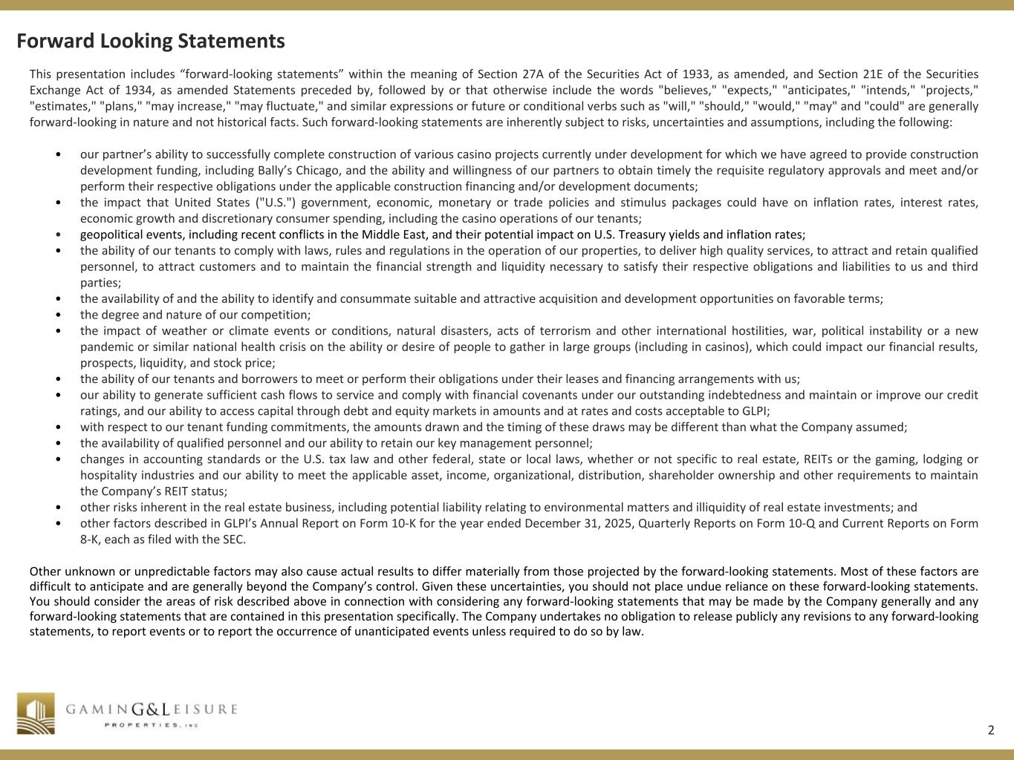
2 R 41 G 41 B 41 R 255 G 255 B 255 R 207 G 182 B 103 R 163 G 131 B 56 R 31 G 73 B 125 R 144 G 124 B 75 R 79 G 129 B 189 R 235 G 235 B 237 R 128 G 100 B 162 R 199 G 198 B 215 This presentation includes “forward-looking statements” within the meaning of Section 27A of the Securities Act of 1933, as amended, and Section 21E of the Securities Exchange Act of 1934, as amended Statements preceded by, followed by or that otherwise include the words "believes," "expects," "anticipates," "intends," "projects," "estimates," "plans," "may increase," "may fluctuate," and similar expressions or future or conditional verbs such as "will," "should," "would," "may" and "could" are generally forward-looking in nature and not historical facts. Such forward-looking statements are inherently subject to risks, uncertainties and assumptions, including the following: • our partner’s ability to successfully complete construction of various casino projects currently under development for which we have agreed to provide construction development funding, including Bally’s Chicago, and the ability and willingness of our partners to obtain timely the requisite regulatory approvals and meet and/or perform their respective obligations under the applicable construction financing and/or development documents; • the impact that United States ("U.S.") government, economic, monetary or trade policies and stimulus packages could have on inflation rates, interest rates, economic growth and discretionary consumer spending, including the casino operations of our tenants; • geopolitical events, including recent conflicts in the Middle East, and their potential impact on U.S. Treasury yields and inflation rates; • the ability of our tenants to comply with laws, rules and regulations in the operation of our properties, to deliver high quality services, to attract and retain qualified personnel, to attract customers and to maintain the financial strength and liquidity necessary to satisfy their respective obligations and liabilities to us and third parties; • the availability of and the ability to identify and consummate suitable and attractive acquisition and development opportunities on favorable terms; • the degree and nature of our competition; • the impact of weather or climate events or conditions, natural disasters, acts of terrorism and other international hostilities, war, political instability or a new pandemic or similar national health crisis on the ability or desire of people to gather in large groups (including in casinos), which could impact our financial results, prospects, liquidity, and stock price; • the ability of our tenants and borrowers to meet or perform their obligations under their leases and financing arrangements with us; • our ability to generate sufficient cash flows to service and comply with financial covenants under our outstanding indebtedness and maintain or improve our credit ratings, and our ability to access capital through debt and equity markets in amounts and at rates and costs acceptable to GLPI; • with respect to our tenant funding commitments, the amounts drawn and the timing of these draws may be different than what the Company assumed; • the availability of qualified personnel and our ability to retain our key management personnel; • changes in accounting standards or the U.S. tax law and other federal, state or local laws, whether or not specific to real estate, REITs or the gaming, lodging or hospitality industries and our ability to meet the applicable asset, income, organizational, distribution, shareholder ownership and other requirements to maintain the Company’s REIT status; • other risks inherent in the real estate business, including potential liability relating to environmental matters and illiquidity of real estate investments; and • other factors described in GLPI’s Annual Report on Form 10-K for the year ended December 31, 2025, Quarterly Reports on Form 10-Q and Current Reports on Form 8-K, each as filed with the SEC. Other unknown or unpredictable factors may also cause actual results to differ materially from those projected by the forward-looking statements. Most of these factors are difficult to anticipate and are generally beyond the Company’s control. Given these uncertainties, you should not place undue reliance on these forward-looking statements. You should consider the areas of risk described above in connection with considering any forward-looking statements that may be made by the Company generally and any forward-looking statements that are contained in this presentation specifically. The Company undertakes no obligation to release publicly any revisions to any forward-looking statements, to report events or to report the occurrence of unanticipated events unless required to do so by law. Forward Looking Statements

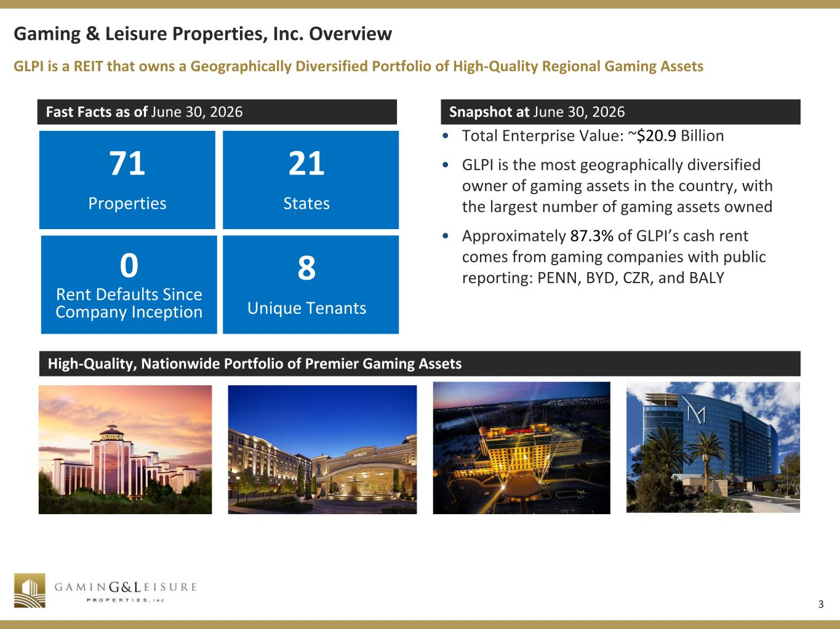
3 R 41 G 41 B 41 R 255 G 255 B 255 R 207 G 182 B 103 R 163 G 131 B 56 R 31 G 73 B 125 R 144 G 124 B 75 R 79 G 129 B 189 R 235 G 235 B 237 R 128 G 100 B 162 R 199 G 198 B 215 Gaming & Leisure Properties, Inc. Overview Fast Facts as of June 30, 2026 Snapshot at June 30, 2026 71 Properties 21 States • Total Enterprise Value: ~$20.9 Billion • GLPI is the most geographically diversified owner of gaming assets in the country, with the largest number of gaming assets owned • Approximately 87.3% of GLPI’s cash rent comes from gaming companies with public reporting: PENN, BYD, CZR, and BALY High-Quality, Nationwide Portfolio of Premier Gaming Assets GLPI is a REIT that owns a Geographically Diversified Portfolio of High-Quality Regional Gaming Assets 0 Rent Defaults Since Company Inception 8 Unique Tenants

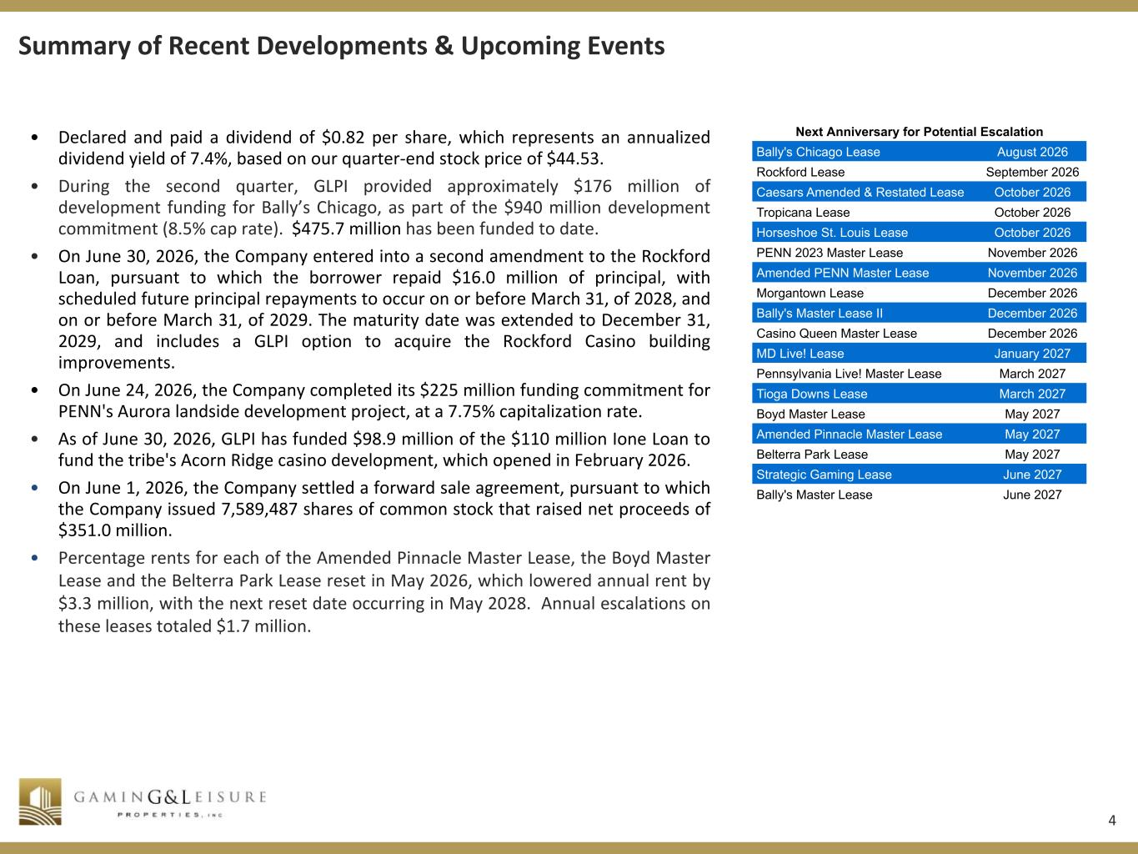
4 R 41 G 41 B 41 R 255 G 255 B 255 R 207 G 182 B 103 R 163 G 131 B 56 R 31 G 73 B 125 R 144 G 124 B 75 R 79 G 129 B 189 R 235 G 235 B 237 R 128 G 100 B 162 R 199 G 198 B 215 Summary of Recent Developments & Upcoming Events • Declared and paid a dividend of $0.82 per share, which represents an annualized dividend yield of 7.4%, based on our quarter-end stock price of $44.53. • During the second quarter, GLPI provided approximately $176 million of development funding for Bally’s Chicago, as part of the $940 million development commitment (8.5% cap rate). $475.7 million has been funded to date. • On June 30, 2026, the Company entered into a second amendment to the Rockford Loan, pursuant to which the borrower repaid $16.0 million of principal, with scheduled future principal repayments to occur on or before March 31, of 2028, and on or before March 31, of 2029. The maturity date was extended to December 31, 2029, and includes a GLPI option to acquire the Rockford Casino building improvements. • On June 24, 2026, the Company completed its $225 million funding commitment for PENN's Aurora landside development project, at a 7.75% capitalization rate. • As of June 30, 2026, GLPI has funded $98.9 million of the $110 million Ione Loan to fund the tribe's Acorn Ridge casino development, which opened in February 2026. • On June 1, 2026, the Company settled a forward sale agreement, pursuant to which the Company issued 7,589,487 shares of common stock that raised net proceeds of $351.0 million. • Percentage rents for each of the Amended Pinnacle Master Lease, the Boyd Master Lease and the Belterra Park Lease reset in May 2026, which lowered annual rent by $3.3 million, with the next reset date occurring in May 2028. Annual escalations on these leases totaled $1.7 million. Next Anniversary for Potential Escalation Bally's Chicago Lease August 2026 Rockford Lease September 2026 Caesars Amended & Restated Lease October 2026 Tropicana Lease October 2026 Horseshoe St. Louis Lease October 2026 PENN 2023 Master Lease November 2026 Amended PENN Master Lease November 2026 Morgantown Lease December 2026 Bally's Master Lease II December 2026 Casino Queen Master Lease December 2026 MD Live! Lease January 2027 Pennsylvania Live! Master Lease March 2027 Tioga Downs Lease March 2027 Boyd Master Lease May 2027 Amended Pinnacle Master Lease May 2027 Belterra Park Lease May 2027 Strategic Gaming Lease June 2027 Bally's Master Lease June 2027

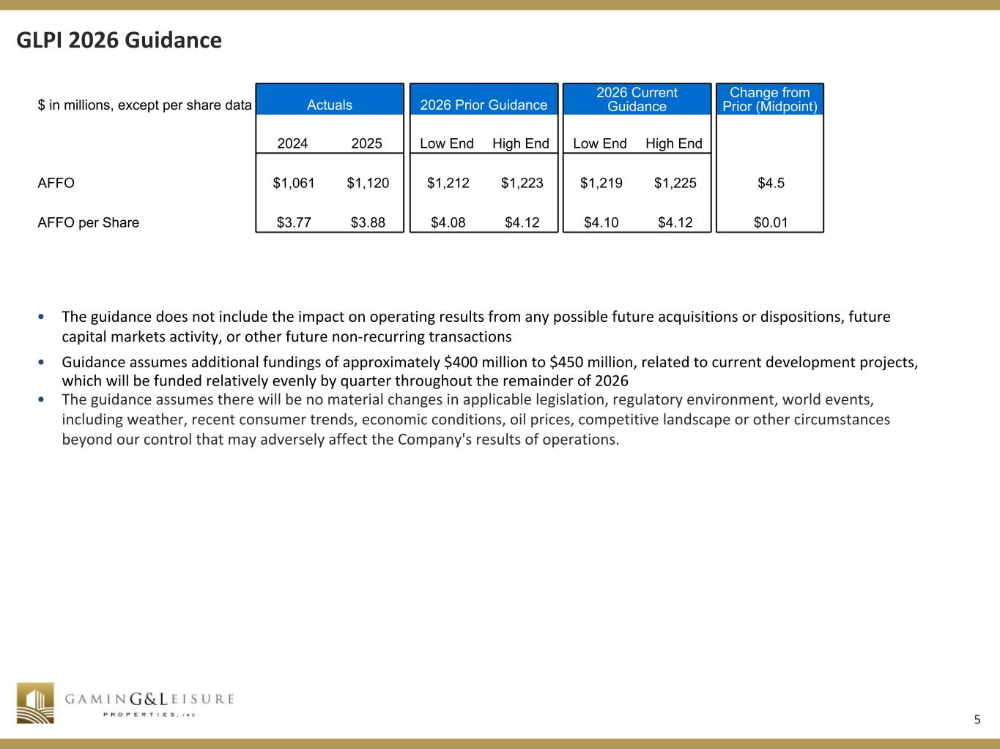
5 R 41 G 41 B 41 R 255 G 255 B 255 R 207 G 182 B 103 R 163 G 131 B 56 R 31 G 73 B 125 R 144 G 124 B 75 R 79 G 129 B 189 R 235 G 235 B 237 R 128 G 100 B 162 R 199 G 198 B 215 GLPI 2026 Guidance • The guidance does not include the impact on operating results from any possible future acquisitions or dispositions, future capital markets activity, or other future non-recurring transactions • Guidance assumes additional fundings of approximately $400 million to $450 million, related to current development projects, which will be funded relatively evenly by quarter throughout the remainder of 2026 • The guidance assumes there will be no material changes in applicable legislation, regulatory environment, world events, including weather, recent consumer trends, economic conditions, oil prices, competitive landscape or other circumstances beyond our control that may adversely affect the Company's results of operations. $ in millions, except per share data Actuals 2026 Prior Guidance 2026 Current Guidance Change from Prior (Midpoint) 2024 2025 Low End High End Low End High End AFFO $1,061 $1,120 $1,212 $1,223 $1,219 $1,225 $4.5 AFFO per Share $3.77 $3.88 $4.08 $4.12 $4.10 $4.12 $0.01

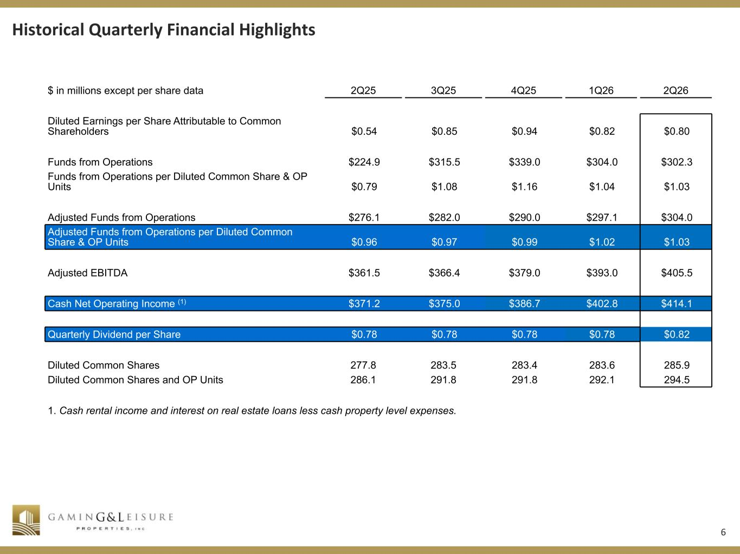
6 R 41 G 41 B 41 R 255 G 255 B 255 R 207 G 182 B 103 R 163 G 131 B 56 R 31 G 73 B 125 R 144 G 124 B 75 R 79 G 129 B 189 R 235 G 235 B 237 R 128 G 100 B 162 R 199 G 198 B 215 Historical Quarterly Financial Highlights $ in millions except per share data 2Q25 3Q25 4Q25 1Q26 2Q26 Diluted Earnings per Share Attributable to Common Shareholders $0.54 $0.85 $0.94 $0.82 $0.80 Funds from Operations $224.9 $315.5 $339.0 $304.0 $302.3 Funds from Operations per Diluted Common Share & OP Units $0.79 $1.08 $1.16 $1.04 $1.03 Adjusted Funds from Operations $276.1 $282.0 $290.0 $297.1 $304.0 Adjusted Funds from Operations per Diluted Common Share & OP Units $0.96 $0.97 $0.99 $1.02 $1.03 Adjusted EBITDA $361.5 $366.4 $379.0 $393.0 $405.5 Cash Net Operating Income (1) $371.2 $375.0 $386.7 $402.8 $414.1 Quarterly Dividend per Share $0.78 $0.78 $0.78 $0.78 $0.82 Diluted Common Shares 277.8 283.5 283.4 283.6 285.9 Diluted Common Shares and OP Units 286.1 291.8 291.8 292.1 294.5 1. Cash rental income and interest on real estate loans less cash property level expenses.

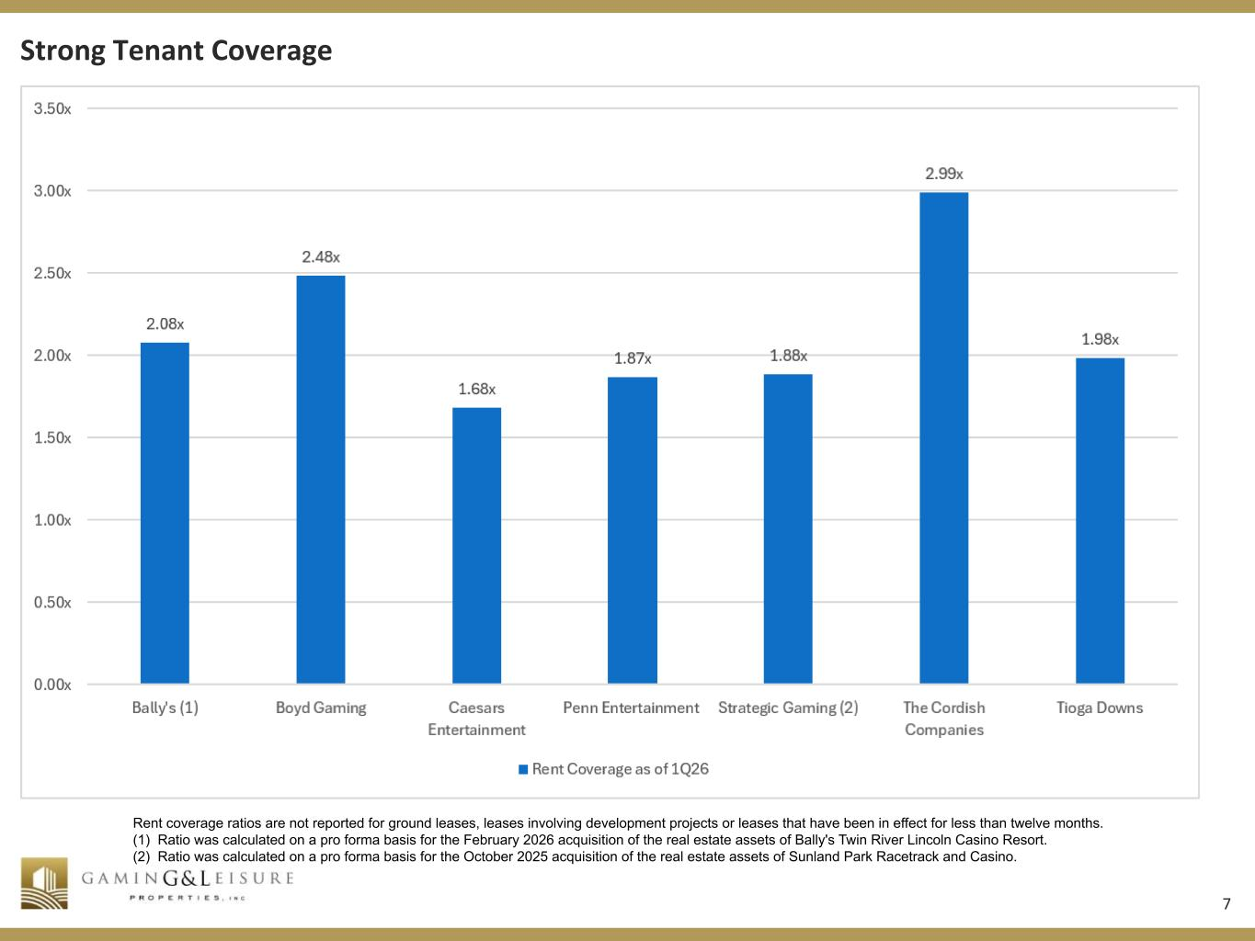
7 R 41 G 41 B 41 R 255 G 255 B 255 R 207 G 182 B 103 R 163 G 131 B 56 R 31 G 73 B 125 R 144 G 124 B 75 R 79 G 129 B 189 R 235 G 235 B 237 R 128 G 100 B 162 R 199 G 198 B 215 Strong Tenant Coverage Rent coverage ratios are not reported for ground leases, leases involving development projects or leases that have been in effect for less than twelve months. (1) Ratio was calculated on a pro forma basis for the February 2026 acquisition of the real estate assets of Bally's Twin River Lincoln Casino Resort. (2) Ratio was calculated on a pro forma basis for the October 2025 acquisition of the real estate assets of Sunland Park Racetrack and Casino.

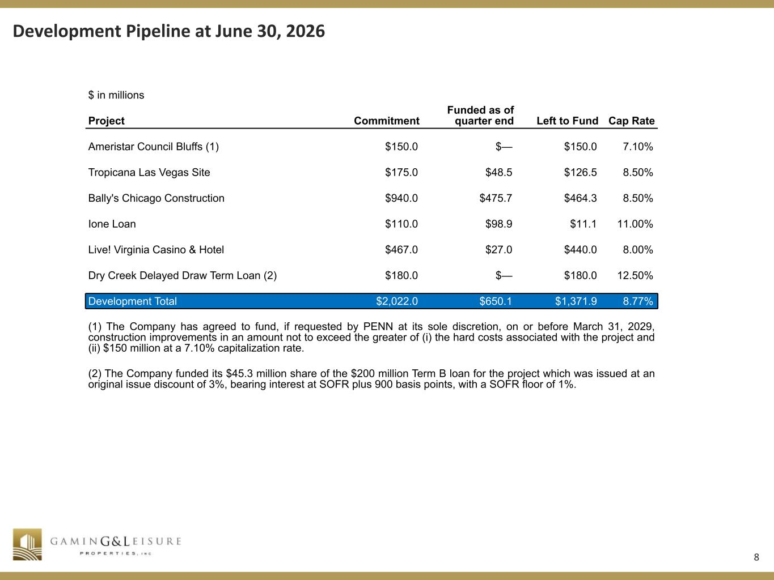
8 R 41 G 41 B 41 R 255 G 255 B 255 R 207 G 182 B 103 R 163 G 131 B 56 R 31 G 73 B 125 R 144 G 124 B 75 R 79 G 129 B 189 R 235 G 235 B 237 R 128 G 100 B 162 R 199 G 198 B 215 Development Pipeline at June 30, 2026 $ in millions Project Commitment Funded as of quarter end Left to Fund Cap Rate Ameristar Council Bluffs (1) $150.0 $— $150.0 7.10% Tropicana Las Vegas Site $175.0 $48.5 $126.5 8.50% Bally's Chicago Construction $940.0 $475.7 $464.3 8.50% Ione Loan $110.0 $98.9 $11.1 11.00% Live! Virginia Casino & Hotel $467.0 $27.0 $440.0 8.00% Dry Creek Delayed Draw Term Loan (2) $180.0 $— $180.0 12.50% Development Total $2,022.0 $650.1 $1,371.9 8.77% (1) The Company has agreed to fund, if requested by PENN at its sole discretion, on or before March 31, 2029, construction improvements in an amount not to exceed the greater of (i) the hard costs associated with the project and (ii) $150 million at a 7.10% capitalization rate. (2) The Company funded its $45.3 million share of the $200 million Term B loan for the project which was issued at an original issue discount of 3%, bearing interest at SOFR plus 900 basis points, with a SOFR floor of 1%.

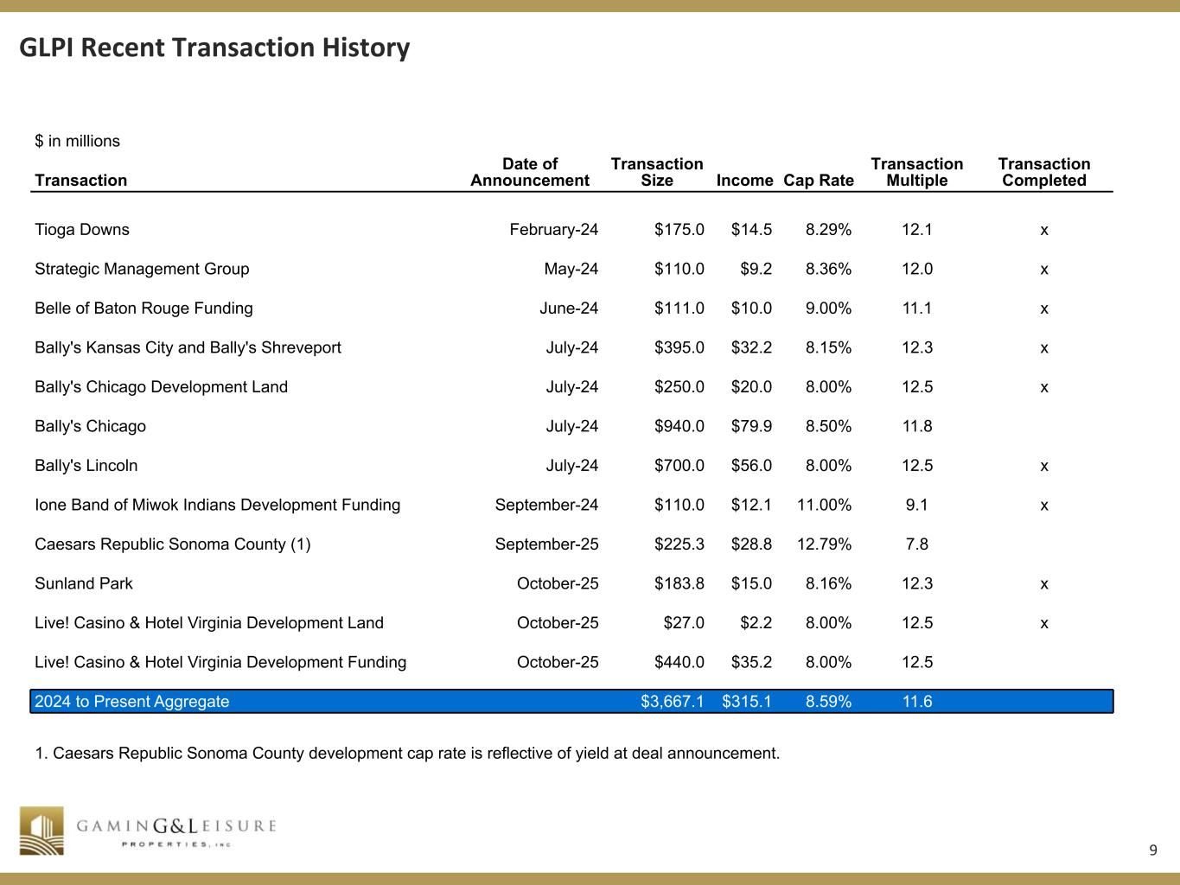
9 R 41 G 41 B 41 R 255 G 255 B 255 R 207 G 182 B 103 R 163 G 131 B 56 R 31 G 73 B 125 R 144 G 124 B 75 R 79 G 129 B 189 R 235 G 235 B 237 R 128 G 100 B 162 R 199 G 198 B 215 GLPI Recent Transaction History $ in millions Transaction Date of Announcement Transaction Size Income Cap Rate Transaction Multiple Transaction Completed Tioga Downs February-24 $175.0 $14.5 8.29% 12.1 x Strategic Management Group May-24 $110.0 $9.2 8.36% 12.0 x Belle of Baton Rouge Funding June-24 $111.0 $10.0 9.00% 11.1 x Bally's Kansas City and Bally's Shreveport July-24 $395.0 $32.2 8.15% 12.3 x Bally's Chicago Development Land July-24 $250.0 $20.0 8.00% 12.5 x Bally's Chicago July-24 $940.0 $79.9 8.50% 11.8 Bally's Lincoln July-24 $700.0 $56.0 8.00% 12.5 x Ione Band of Miwok Indians Development Funding September-24 $110.0 $12.1 11.00% 9.1 x Caesars Republic Sonoma County (1) September-25 $225.3 $28.8 12.79% 7.8 Sunland Park October-25 $183.8 $15.0 8.16% 12.3 x Live! Casino & Hotel Virginia Development Land October-25 $27.0 $2.2 8.00% 12.5 x Live! Casino & Hotel Virginia Development Funding October-25 $440.0 $35.2 8.00% 12.5 2024 to Present Aggregate $3,667.1 $315.1 8.59% 11.6 1. Caesars Republic Sonoma County development cap rate is reflective of yield at deal announcement.

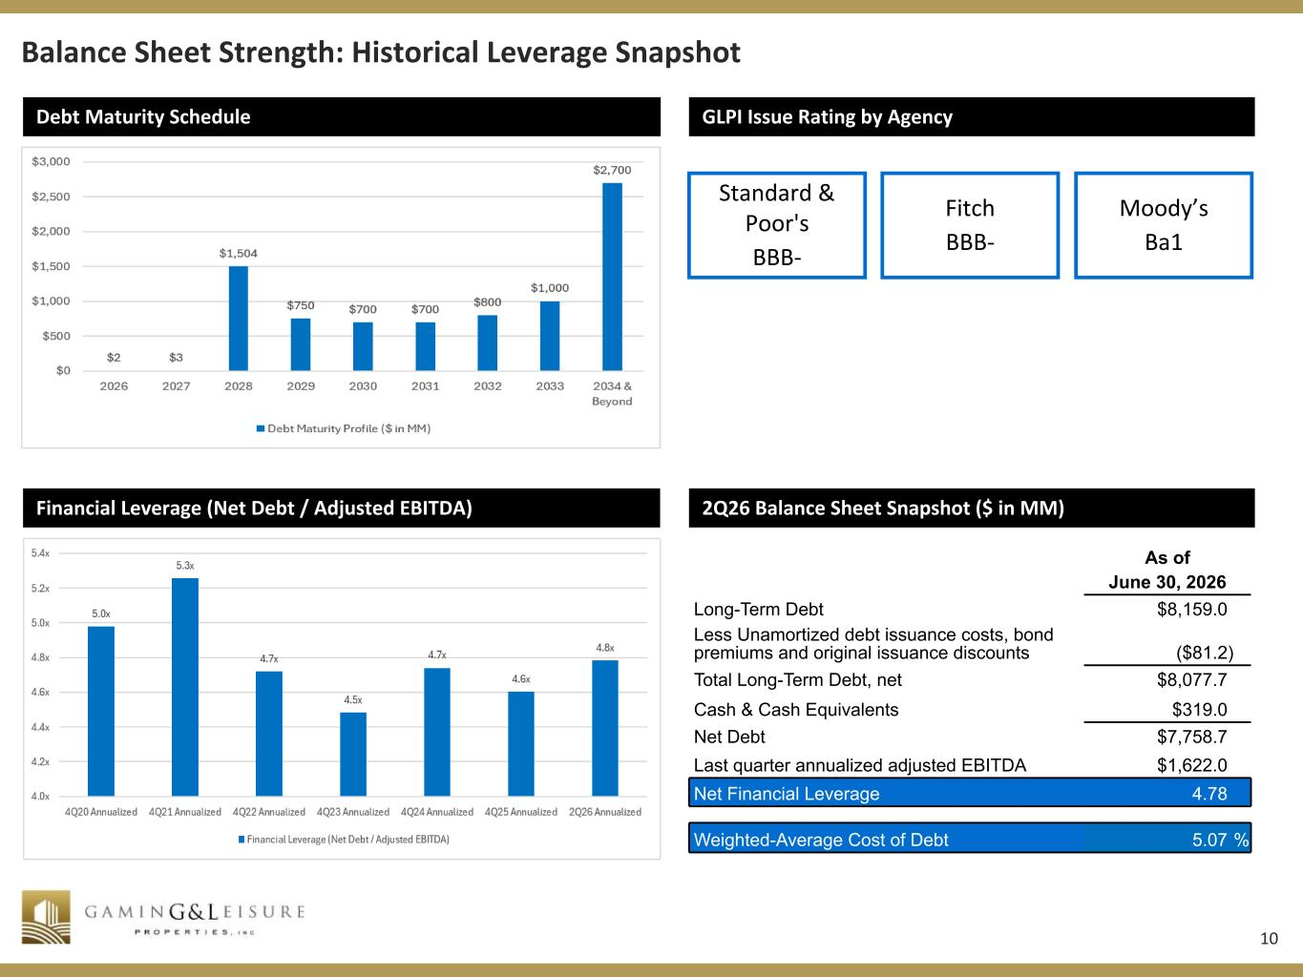
10 R 41 G 41 B 41 R 255 G 255 B 255 R 207 G 182 B 103 R 163 G 131 B 56 R 31 G 73 B 125 R 144 G 124 B 75 R 79 G 129 B 189 R 235 G 235 B 237 R 128 G 100 B 162 R 199 G 198 B 215 Debt Maturity Schedule Balance Sheet Strength: Historical Leverage Snapshot GLPI Issue Rating by Agency Fitch BBB- Moody’s Ba1 Financial Leverage (Net Debt / Adjusted EBITDA) 2Q26 Balance Sheet Snapshot ($ in MM) As of June 30, 2026 Long-Term Debt $8,159.0 Less Unamortized debt issuance costs, bond premiums and original issuance discounts ($81.2) Total Long-Term Debt, net $8,077.7 Cash & Cash Equivalents $319.0 Net Debt $7,758.7 Last quarter annualized adjusted EBITDA $1,622.0 Net Financial Leverage 4.78 Weighted-Average Cost of Debt 5.07 % Standard & Poor's BBB-

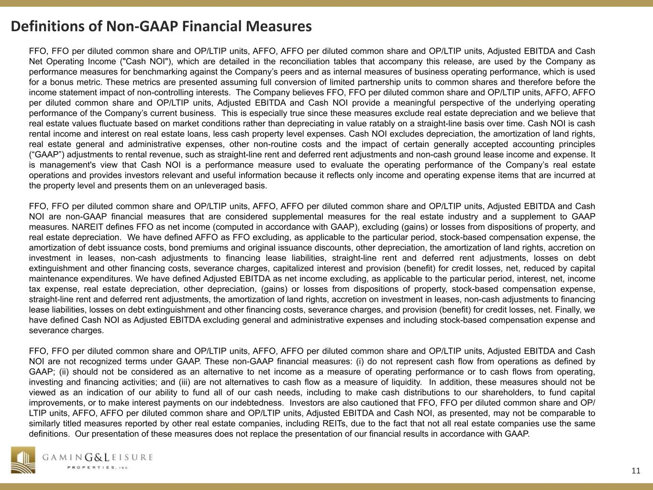
11 R 41 G 41 B 41 R 255 G 255 B 255 R 207 G 182 B 103 R 163 G 131 B 56 R 31 G 73 B 125 R 144 G 124 B 75 R 79 G 129 B 189 R 235 G 235 B 237 R 128 G 100 B 162 R 199 G 198 B 215 FFO, FFO per diluted common share and OP/LTIP units, AFFO, AFFO per diluted common share and OP/LTIP units, Adjusted EBITDA and Cash Net Operating Income ("Cash NOI"), which are detailed in the reconciliation tables that accompany this release, are used by the Company as performance measures for benchmarking against the Company’s peers and as internal measures of business operating performance, which is used for a bonus metric. These metrics are presented assuming full conversion of limited partnership units to common shares and therefore before the income statement impact of non-controlling interests. The Company believes FFO, FFO per diluted common share and OP/LTIP units, AFFO, AFFO per diluted common share and OP/LTIP units, Adjusted EBITDA and Cash NOI provide a meaningful perspective of the underlying operating performance of the Company’s current business. This is especially true since these measures exclude real estate depreciation and we believe that real estate values fluctuate based on market conditions rather than depreciating in value ratably on a straight-line basis over time. Cash NOI is cash rental income and interest on real estate loans, less cash property level expenses. Cash NOI excludes depreciation, the amortization of land rights, real estate general and administrative expenses, other non-routine costs and the impact of certain generally accepted accounting principles (“GAAP”) adjustments to rental revenue, such as straight-line rent and deferred rent adjustments and non-cash ground lease income and expense. It is management's view that Cash NOI is a performance measure used to evaluate the operating performance of the Company’s real estate operations and provides investors relevant and useful information because it reflects only income and operating expense items that are incurred at the property level and presents them on an unleveraged basis. FFO, FFO per diluted common share and OP/LTIP units, AFFO, AFFO per diluted common share and OP/LTIP units, Adjusted EBITDA and Cash NOI are non-GAAP financial measures that are considered supplemental measures for the real estate industry and a supplement to GAAP measures. NAREIT defines FFO as net income (computed in accordance with GAAP), excluding (gains) or losses from dispositions of property, and real estate depreciation. We have defined AFFO as FFO excluding, as applicable to the particular period, stock-based compensation expense, the amortization of debt issuance costs, bond premiums and original issuance discounts, other depreciation, the amortization of land rights, accretion on investment in leases, non-cash adjustments to financing lease liabilities, straight-line rent and deferred rent adjustments, losses on debt extinguishment and other financing costs, severance charges, capitalized interest and provision (benefit) for credit losses, net, reduced by capital maintenance expenditures. We have defined Adjusted EBITDA as net income excluding, as applicable to the particular period, interest, net, income tax expense, real estate depreciation, other depreciation, (gains) or losses from dispositions of property, stock-based compensation expense, straight-line rent and deferred rent adjustments, the amortization of land rights, accretion on investment in leases, non-cash adjustments to financing lease liabilities, losses on debt extinguishment and other financing costs, severance charges, and provision (benefit) for credit losses, net. Finally, we have defined Cash NOI as Adjusted EBITDA excluding general and administrative expenses and including stock-based compensation expense and severance charges. FFO, FFO per diluted common share and OP/LTIP units, AFFO, AFFO per diluted common share and OP/LTIP units, Adjusted EBITDA and Cash NOI are not recognized terms under GAAP. These non-GAAP financial measures: (i) do not represent cash flow from operations as defined by GAAP; (ii) should not be considered as an alternative to net income as a measure of operating performance or to cash flows from operating, investing and financing activities; and (iii) are not alternatives to cash flow as a measure of liquidity. In addition, these measures should not be viewed as an indication of our ability to fund all of our cash needs, including to make cash distributions to our shareholders, to fund capital improvements, or to make interest payments on our indebtedness. Investors are also cautioned that FFO, FFO per diluted common share and OP/ LTIP units, AFFO, AFFO per diluted common share and OP/LTIP units, Adjusted EBITDA and Cash NOI, as presented, may not be comparable to similarly titled measures reported by other real estate companies, including REITs, due to the fact that not all real estate companies use the same definitions. Our presentation of these measures does not replace the presentation of our financial results in accordance with GAAP. Definitions of Non-GAAP Financial Measures

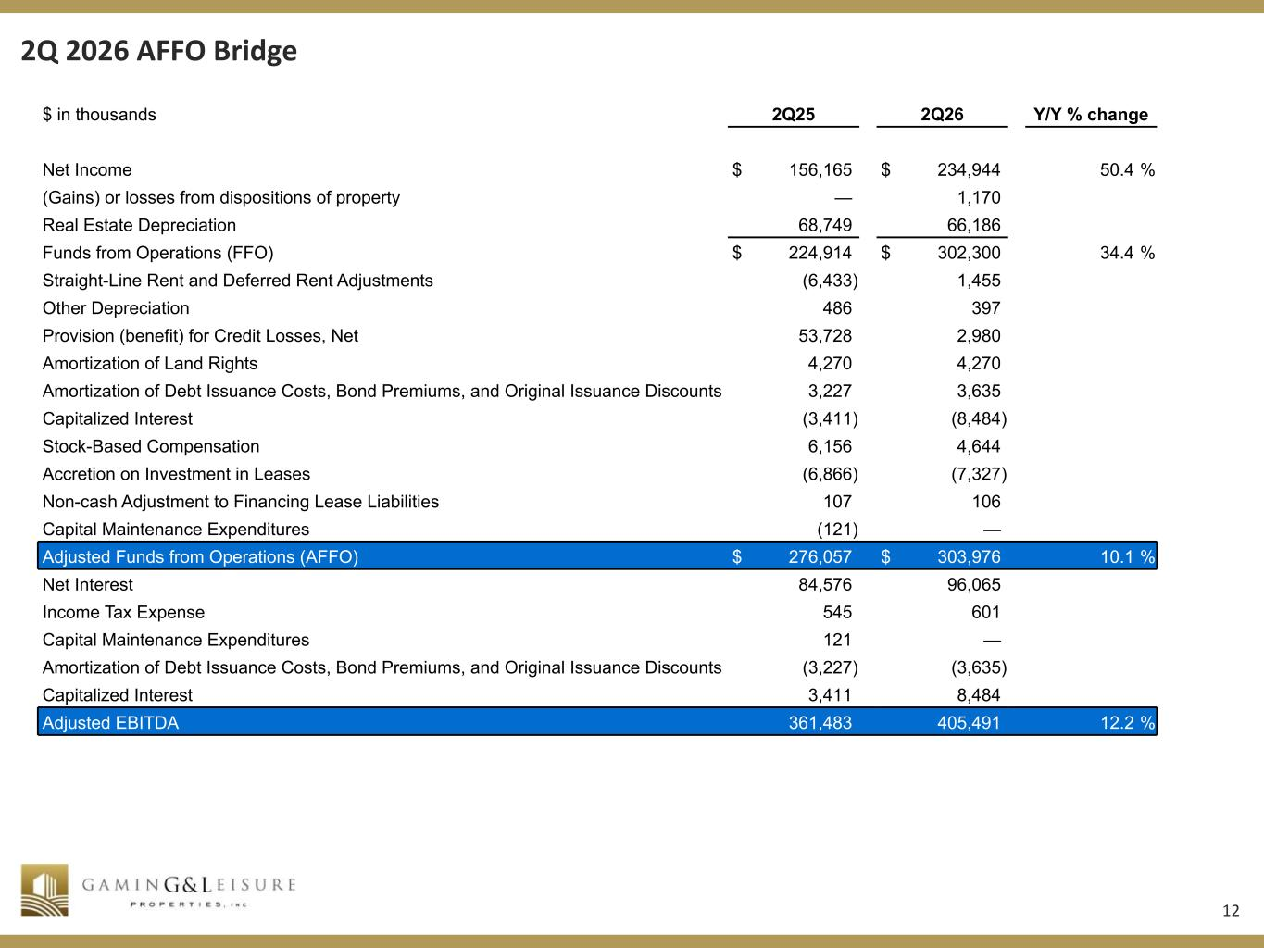
12 R 41 G 41 B 41 R 255 G 255 B 255 R 207 G 182 B 103 R 163 G 131 B 56 R 31 G 73 B 125 R 144 G 124 B 75 R 79 G 129 B 189 R 235 G 235 B 237 R 128 G 100 B 162 R 199 G 198 B 215 2Q 2026 AFFO Bridge $ in thousands 2Q25 2Q26 Y/Y % change Net Income $ 156,165 $ 234,944 50.4 % (Gains) or losses from dispositions of property — 1,170 Real Estate Depreciation 68,749 66,186 Funds from Operations (FFO) $ 224,914 $ 302,300 34.4 % Straight-Line Rent and Deferred Rent Adjustments (6,433) 1,455 Other Depreciation 486 397 Provision (benefit) for Credit Losses, Net 53,728 2,980 Amortization of Land Rights 4,270 4,270 Amortization of Debt Issuance Costs, Bond Premiums, and Original Issuance Discounts 3,227 3,635 Capitalized Interest (3,411) (8,484) Stock-Based Compensation 6,156 4,644 Accretion on Investment in Leases (6,866) (7,327) Non-cash Adjustment to Financing Lease Liabilities 107 106 Capital Maintenance Expenditures (121) — Adjusted Funds from Operations (AFFO) $ 276,057 $ 303,976 10.1 % Net Interest 84,576 96,065 Income Tax Expense 545 601 Capital Maintenance Expenditures 121 — Amortization of Debt Issuance Costs, Bond Premiums, and Original Issuance Discounts (3,227) (3,635) Capitalized Interest 3,411 8,484 Adjusted EBITDA 361,483 405,491 12.2 %

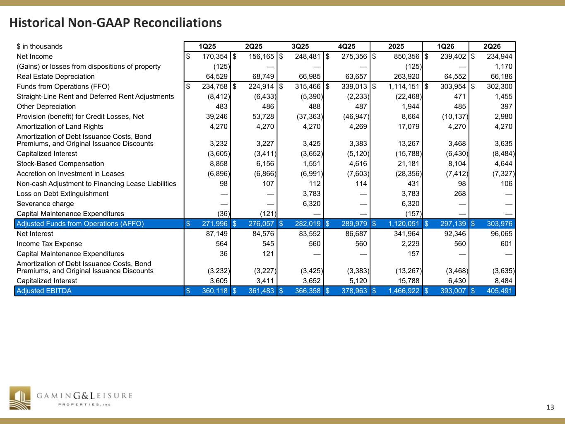
13 R 41 G 41 B 41 R 255 G 255 B 255 R 207 G 182 B 103 R 163 G 131 B 56 R 31 G 73 B 125 R 144 G 124 B 75 R 79 G 129 B 189 R 235 G 235 B 237 R 128 G 100 B 162 R 199 G 198 B 215 Historical Non-GAAP Reconciliations $ in thousands 1Q25 2Q25 3Q25 4Q25 2025 1Q26 2Q26 Net Income $ 170,354 $ 156,165 $ 248,481 $ 275,356 $ 850,356 $ 239,402 $ 234,944 (Gains) or losses from dispositions of property (125) — — — (125) — 1,170 Real Estate Depreciation 64,529 68,749 66,985 63,657 263,920 64,552 66,186 Funds from Operations (FFO) $ 234,758 $ 224,914 $ 315,466 $ 339,013 $ 1,114,151 $ 303,954 $ 302,300 Straight-Line Rent and Deferred Rent Adjustments (8,412) (6,433) (5,390) (2,233) (22,468) 471 1,455 Other Depreciation 483 486 488 487 1,944 485 397 Provision (benefit) for Credit Losses, Net 39,246 53,728 (37,363) (46,947) 8,664 (10,137) 2,980 Amortization of Land Rights 4,270 4,270 4,270 4,269 17,079 4,270 4,270 Amortization of Debt Issuance Costs, Bond Premiums, and Original Issuance Discounts 3,232 3,227 3,425 3,383 13,267 3,468 3,635 Capitalized Interest (3,605) (3,411) (3,652) (5,120) (15,788) (6,430) (8,484) Stock-Based Compensation 8,858 6,156 1,551 4,616 21,181 8,104 4,644 Accretion on Investment in Leases (6,896) (6,866) (6,991) (7,603) (28,356) (7,412) (7,327) Non-cash Adjustment to Financing Lease Liabilities 98 107 112 114 431 98 106 Loss on Debt Extinguishment — — 3,783 — 3,783 268 — Severance charge — — 6,320 — 6,320 — — Capital Maintenance Expenditures (36) (121) — — (157) — — Adjusted Funds from Operations (AFFO) $ 271,996 $ 276,057 $ 282,019 $ 289,979 $ 1,120,051 $ 297,139 $ 303,976 Net Interest 87,149 84,576 83,552 86,687 341,964 92,346 96,065 Income Tax Expense 564 545 560 560 2,229 560 601 Capital Maintenance Expenditures 36 121 — — 157 — — Amortization of Debt Issuance Costs, Bond Premiums, and Original Issuance Discounts (3,232) (3,227) (3,425) (3,383) (13,267) (3,468) (3,635) Capitalized Interest 3,605 3,411 3,652 5,120 15,788 6,430 8,484 Adjusted EBITDA $ 360,118 $ 361,483 $ 366,358 $ 378,963 $ 1,466,922 $ 393,007 $ 405,491



